**Developing Soft and Parallel Programming Skills**

**Using Project – Based Learning**

CSC 3210 Spring – 2020

8 – Bit

Landon Wang

Raejae Sandy

Tony Ngo

**Planning and Scheduling**

**Work Breakdown Structure**

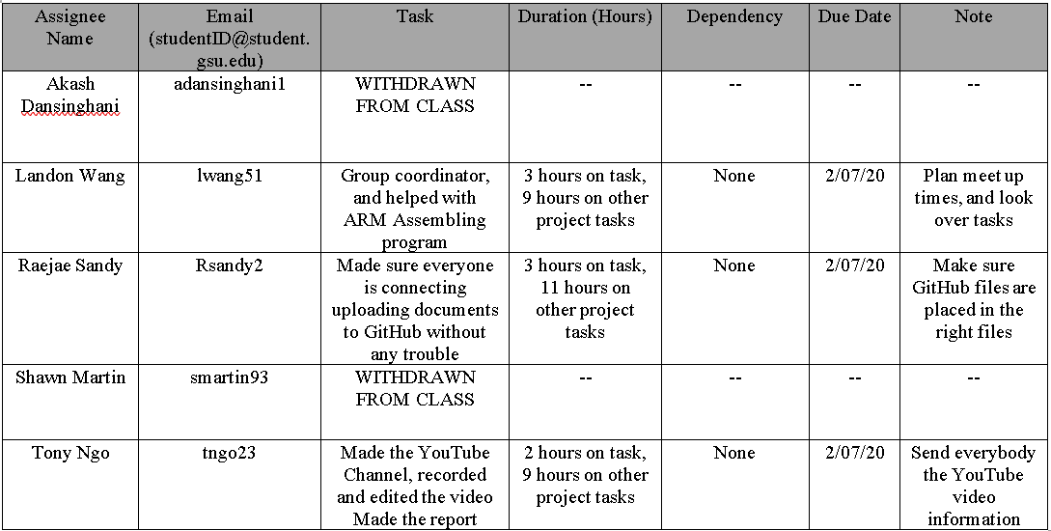

**GitHub Project Page**

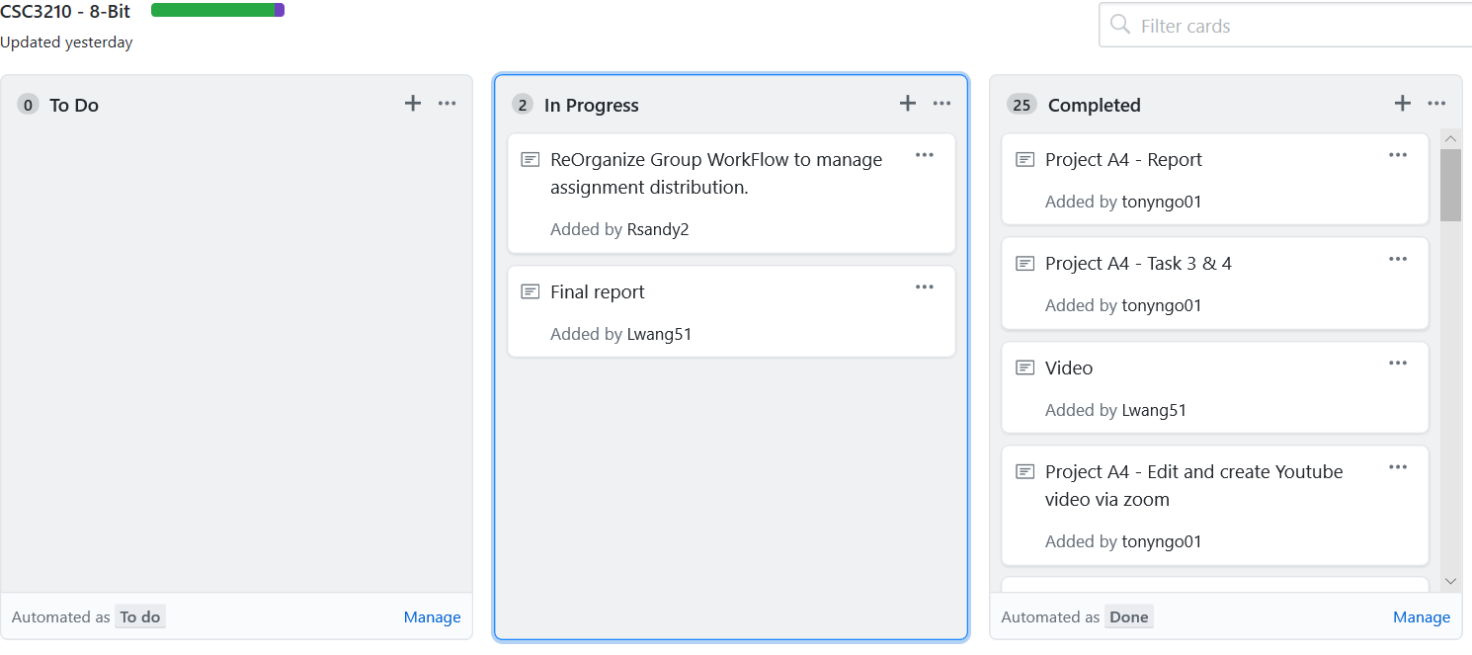

**Parallel Programming Skills and Basics**

**Parallel Programming Skills**

By: Landon Wang

* (15p) Race condition:
  + (2p) What is race condition?

**Also known as race hazard, is an electronics’, software’s or other system’s behavior where the result is depends on sequence or timing g uncontrollable events. This can cause issues when event do not happen in the correct order. This usually occurs in logic circuits, and in multithreaded/distributed programs.**

* + (5p) Why race condition is difficult to reproduce and debug?

**Race conditions can be difficult to reproduce and debug, because the result cannot be determined as it depends on the relative timing between interfering threads. Problems that occur in the production system(s) can disappear in debug mode when more logging is added or when attaching a debugger (mostly referred to as “Heisenbug”). Because of this, programmers usually avoid race conditions by carefully designing the program rather than going back and fixing them.**

* + (8p) How can it be fixed? Provide an example from your Project_A2 (see spmd2.c).

**To fix race condition errors, we need to declare variable in a way that each forked thread has their own private variable instead of a shared variable. This is because critical race conditions usually occur when processes depend on shared state. Operations that uses a shared state are important sections that must be mutually exclusive. Looking back at the spmd2.c program from project A2, if we initialized id and numThreads outside of the #pragma omp parallel block, we will get race conditions. This is because the forked threads will all share the same id and numthreads. To fix this issue, we simply initialize id and numThreads inside the #pragma omp parallel block, which allows each forked thread to have its own private id and numThreads.**

* (15p) Summaries the Parallel Programming Patterns section in the “Introduction to Parallel Computing_3.pdf” (two pages) in your own words (one paragraph, no more than 150 words).

**In the strategies pattern, software developers have to decide what algorithmic strategies to use and given that, the implementation strategies to use. The algorithmic strategy deals with what tasks can be done concurrently by multiple processors working concurrently. Implementation strategy deals with the overall structure of the program or its data structure. In concurrent execution pattern, there are two major categories: process/thread control and coordination pattern. Process control pattern dictates how processes units are controlled during runtime (we have been using this pattern in the previous two projects). Coordination pattern sets up how multiple concurrently running tasks coordinate to complete the computation. There are two major coordination patterns: massage passing and mutual exclusion. Massage passing uses Message Passing Interface (MPI) to pass messages between concurrent processors on multicore machines(s). Mutual exclusion uses OpenMP to share memory applications between threads running on a single shared memory system. Another type of parallel implementation uses hybrid computation, where it uses bother of the coordination patterns on a cluster of machines.**

* (12p) In the section “Categorizing Patterns” in the “Introduction to Parallel Computing_3.pdf” compare the following:
  + Collective synchronization (barrier) with Collective communication (reduction)
    - **Collective Synchronization**
      * **how multiple processes will join up at a certain point**
      * **how multiple copies of a dataset are kept in coherence with one another to maintain data integrity**
    - **Collective Communication**
      * **Each process performs the same communication operations**
      * **Communication and computation are corresponding to group of processes in a communicator**
  + Master-worker with fork join
    - **Master-worker**
      * **Master is responsible of assigning and receiving tasks to and from the worker, and workers are responsible for executing certain sub-task**
      * **After worker completes the task, the result is then submitted to the master, where it will be summarized**
    - **Fork join**
      * **Execution branches off (fork) in parallel at certain point in the program execution, and then merges (join) at a following point to resume sequential execution**
      * **Programs fork (make new) threads when needed, and when a thread finished execution, it will join with the program**
* (26p) Dependency: Using your own words and explanation, answer the following:
  + (3p) Where can we find parallelism in programming?
    - **Statement Level**
      * **Between program statements**
    - **Block/loop/routine/process level**
      * **Larger-grained program statements**
  + (6p) What is dependency and what are its types (provide one example for each)?

**Dependency is when one operation depends on an earlier operation to finish before it can be executed. There are two types of dependency (Fundamental [concurrent] execution assumption and sequential consistency). In fundamental execution assumption, processors run independently from each other and no assumptions are made about their processing speed. For instance, if we want to execute two statements in parallel, we can have processor 1 execute statement 1 while processor 2 executes statement 2. In sequential consistency, the statements that are executed do not interfere with each other, and they produce the same computation results. For example, if we have two statements to execute in parallel, there are two possibilities on how these statements will execute. In the first case, statement 1 can be executed by processor 1 first while statement 2 waits on statement 1 to finish processing before being processed on processor 2. In the second case, statement 2 can be executed by processor 2 first while statement 1 waits on statement 2 to finish processing before being processed on processor 1.**

* + (3p) When a statement is dependent and when it is independent (Provide two examples)?

**A statement is independent when their order of execution does not matter. For example, setting variable A to equal something, then setting variable B to equal something else. A statement is dependent when their execution order affects the computation result. For example, setting variable A to equal something, then setting variable B to equal variable A.**

* + (3p) When can two statements be executed in parallel?

**Two statements can be executed in parallel if and only if there are no dependency between the two statements.**

* + (3p) How can dependency be removed?

**Dependence can be removed by modifying the program, like rearranging or eliminating statements.**

* + 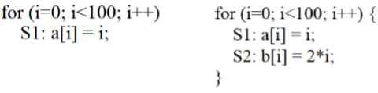(8p) How do we compute dependency for the following two loops and what type/s of dependency?
    - **For the first for loop (true dependence):**

* + - **For the second for loop (true dependence):**

$${S1}^{0} S1^{1} S1^{2} S1^{3} S1^{4}… S1^{99}$$

$$↓ ↓ ↓ ↓ ↓ ↓$$

$${S2}^{0} S2^{1} S2^{2} S2^{3} S2^{4}… S2^{99}$$

**Parallel Programming Basics**

By: Landon Wang

**Integration Using the Trapezoidal Rule**

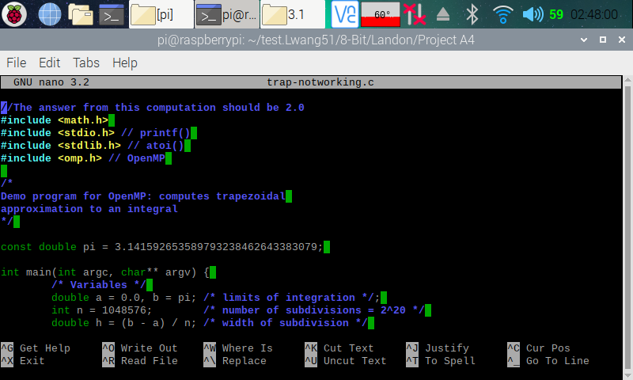

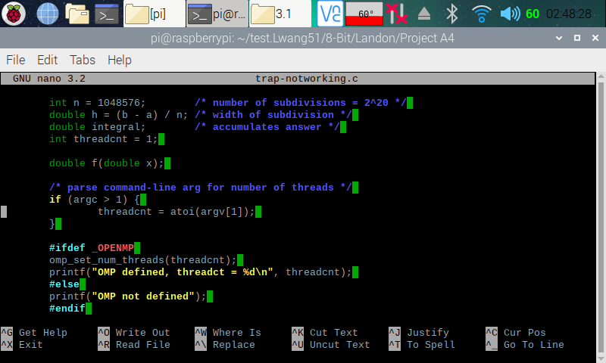

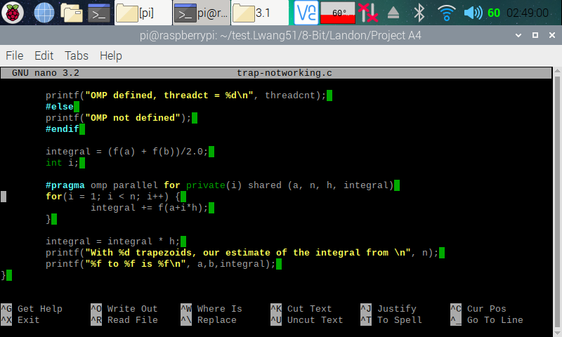

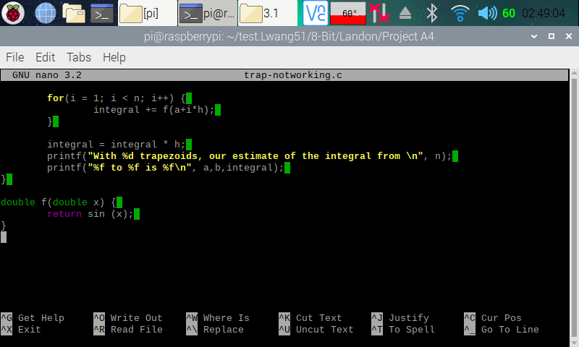

Here (in the four screenshots above), I copied and pasted the codes from the Parallel Programming Task A4 document and used the nano editor to create a program on my Raspberry PI.

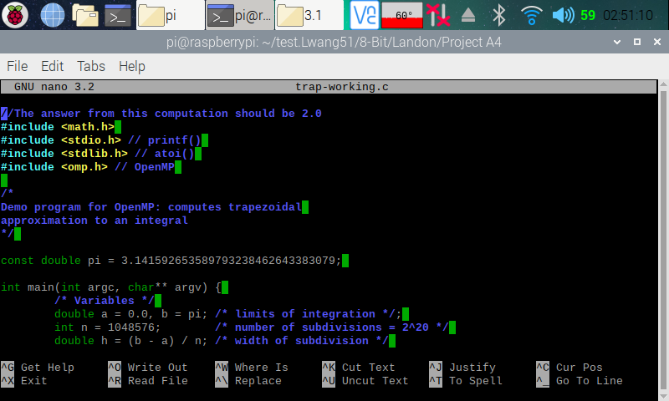

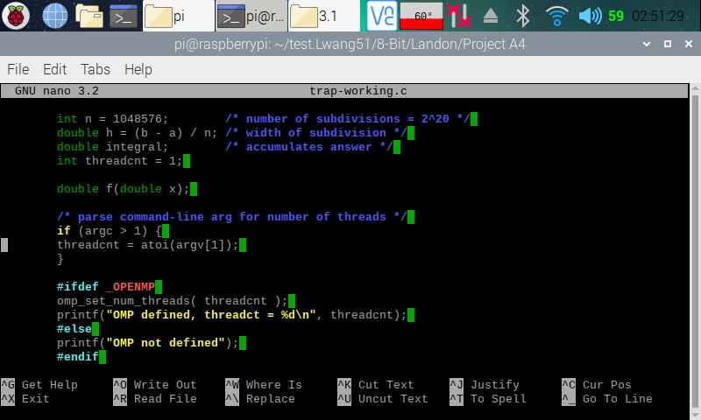

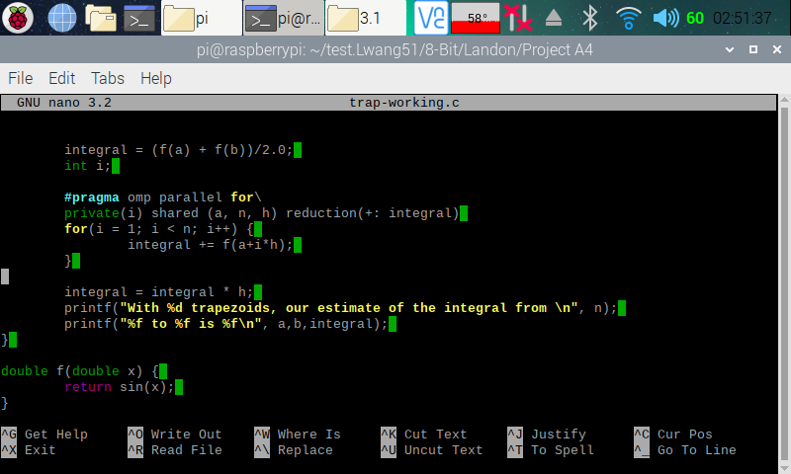

Here (in the three screenshots above), I copied and pasted the codes from the Parallel Programming Task A4 document and used the nano editor to create a program on my Raspberry PI.

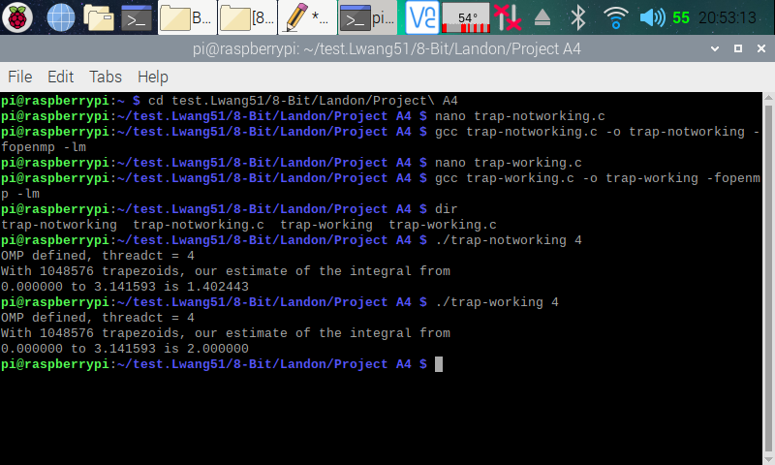

Here (in the screenshot above), I made the executable program for both the trap-notworking.c and trap-working.c programs. I then ran both of the program with a command-line argument that specified to have four threads to b forked. The trap-notworking.c program displayed the result of 1.402443, which we know is not correct from the program comments. The trap-working.c program displayed the result of 2, which we know is correct from the program comments. The reason that trap-notworking.c program displayed the wrong result was because the variable ‘integral’ is being shared across the forked threads. To fix this, we declared the variable ‘integral’ as a reduction pattern, as shown in trap-working.c program.

**Coordination: Synchronization with a Barrier**

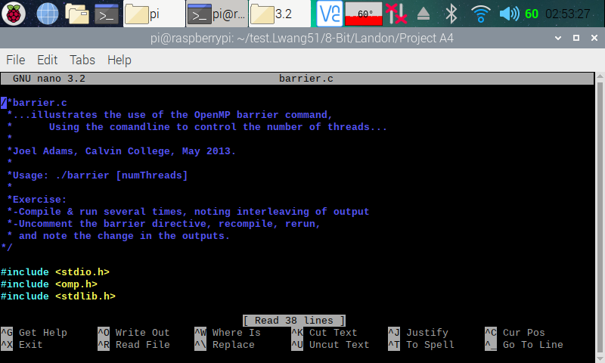

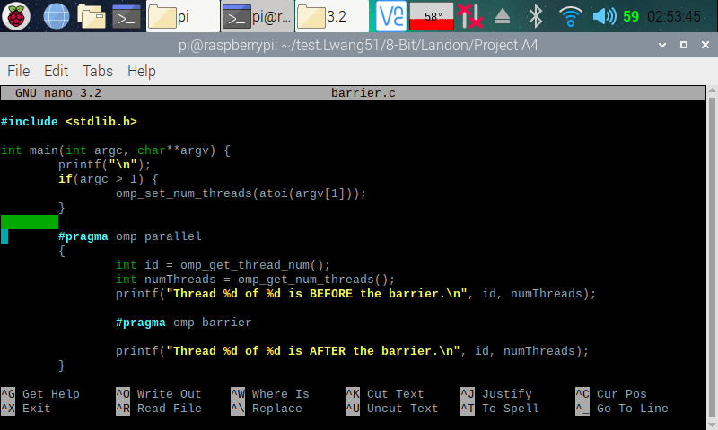

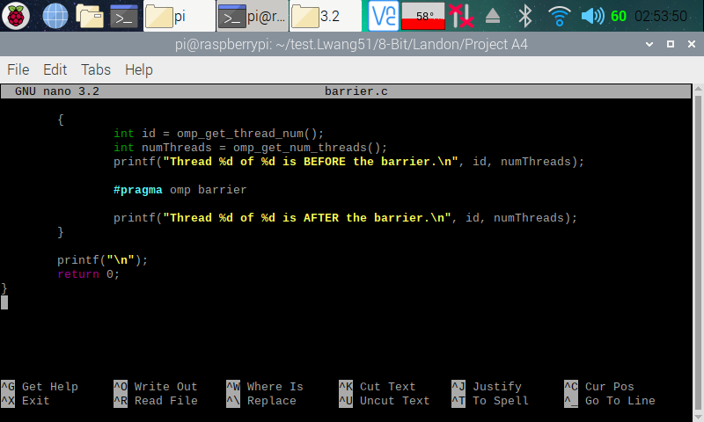

Here (in the three screenshots above), I copied and pasted the codes from the Parallel Programming Task A4 document and used the nano editor to create a program on my Raspberry PI.

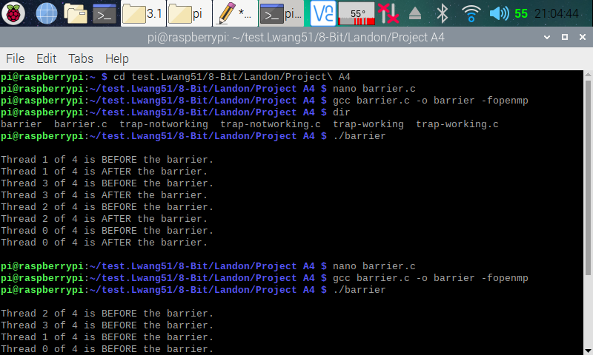

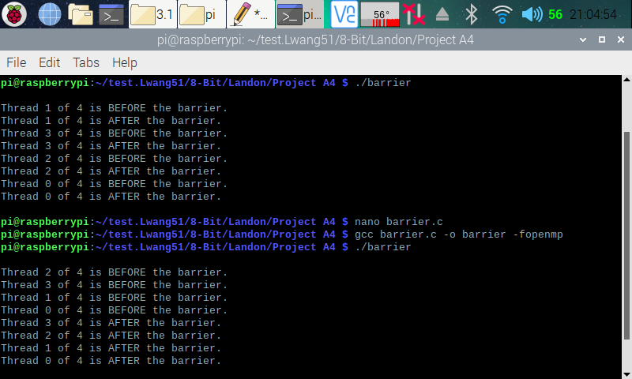

Here (in the two screenshots above), I made an executable file for the barrier.c program. I ran it one time (the first run) with line 31 (#pragma omp barrier) commented out and another time (the second run) with line 31 uncommented. In the first run, we can see that the threads went on and executed their next statement (Thread _ of _ is AFTER the barrier) without waiting for the other “before” threads to finish their execution. In the second run, with the barrier enforced, we see that all threads waited for other threads to finish their “before” threads executing the “after” threads. This is because the barrier forced all threads that reached the point first to wait until all other threads reach the point before allowing them to continue.

**Program Structure: The Master-Worker Implementation Strategy**

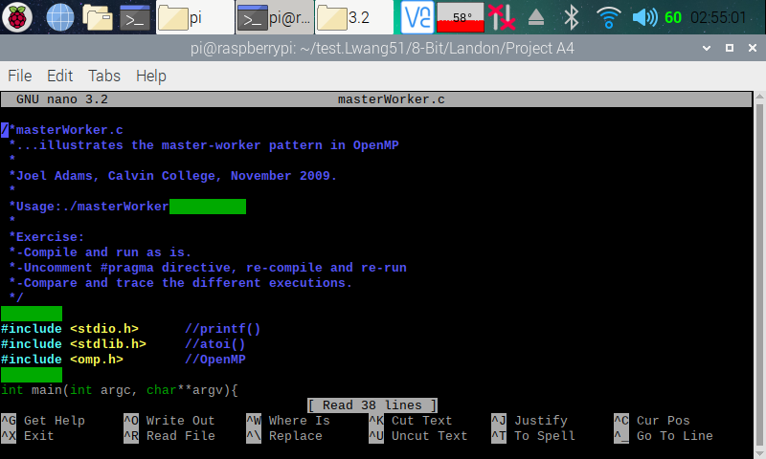

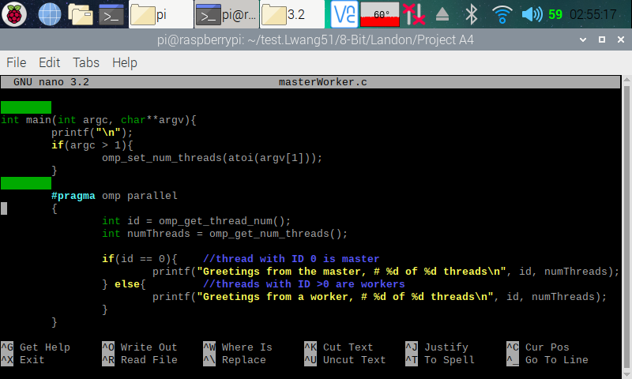

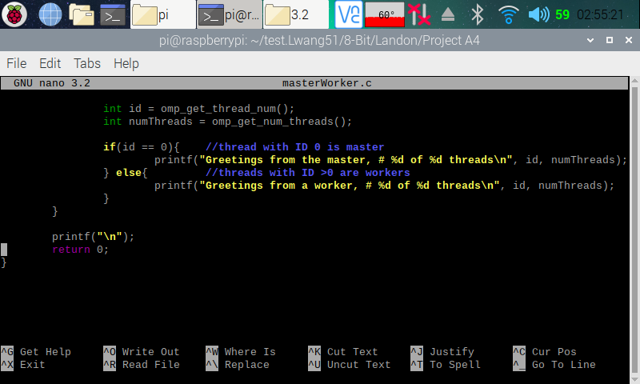

Here (in the three screenshots above), I copied and pasted the codes from the Parallel Programming Task A4 document and used the nano editor to create a program on my Raspberry PI.

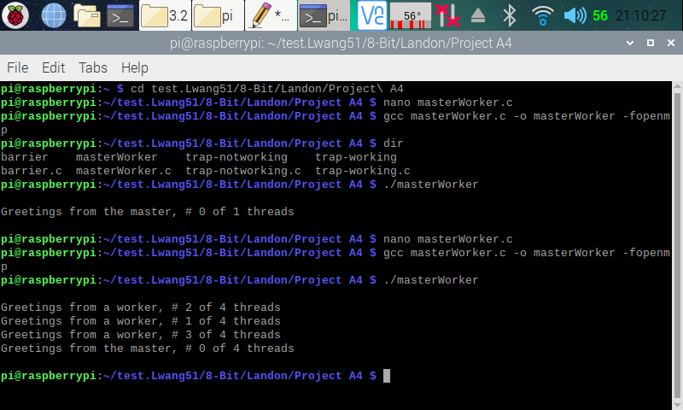

Here (in the screenshot above), I created an executable file for the masterWorker.c program. I ran it one time (the first run) with line 24 (#pragma omp parallel) commented out and another time (the second run) with line 24 uncommented. In the first run, we can see that only a master was created. This is because with line 24 commented out, the program did not run in parallel. After uncommenting line 24, workers were created as the program runs in parallel.

**Parallel Programming Skills**

By: Raejae Sandy

* (15p) ***Race condition:***
  + ***(2p) What is race condition?***

This is Electronics, software or any other system behavior where the result depends on sequence or timing of uncontrollable events. We can see timing issues or chronological inaccuracies when errors occur here.

* + (5p) ***Why race condition is difficult to reproduce and debug?***

Usually programmers don’t even consider Race conditions because of how threads interact with one another. It is considered non-deterministic and is resultant on the relative timing between interfering threads. Because of this, it is not unusual to see problems disappear in debugging.

* + (8p) ***How can it be fixed? Provide an example from your Project_A2 (see spmd2.c).***

Back then one main issue we had was the sharing of variables and states. We want each to be independent of the others and if we go back to older projects when we were working with numThreads without pragma. We shared the same resources or id in that case and then we had our issue. We fixed this condition by giving seperate id’s.

* (15p) ***Summaries the Parallel Programming Patterns section in the “Introduction to Parallel Computing_3.pdf” (two pages) in your own words (one paragraph, no more than 150 words).***

There are multiple patterns described throughout however, each requires a different approach. For example, for strategies pattern developers determine what algorithmic strategy to use. We determine whether we want to run in parallel and distribute or how most efficiently to implement. There is another called concurrent execution pattern where the P/T control (process/thread) pattern where patterns are hidden since they are built in and units are controlled on call or runtime. They offer two types called message parsing and mutual exclusion where one uses MPI to pass messages between processes for different multicore machines and the other uses OpenMP to share memory app. Between threads.

* (12p) ***In the section “Categorizing Patterns” in the “Introduction to Parallel Computing_3.pdf” compare the following:*** 
  + Collective synchronization (barrier) with Collective communication (reduction)
    - Collective Synchronization
      * how multiple processes will join up at a certain point
      * how multiple copies of a dataset are kept in order with one another to balance data integrity
    - Collective Communication
      * Each process performs the same communication operations
  + Master-worker with fork join
    - Master-worker
      * Master is responsible of assigning and receiving tasks to and from the worker, and workers are responsible for executing certain sub-task
      * After worker completes the task, the result is then submitted to the master, where it will be summarized
    - Fork join
      * Execution branches off (fork) in parallel at certain point in the program execution, and then merges (join) at a following point to resume sequential execution
      * Programs fork (make new) threads when needed, and when a thread finished execution, it will join with the program
* (26p) ***Dependency: Using your own words and explanation, answer the following:***
  + ***(3p) Where can we find parallelism in programming?***
    - Statement Level
      * Between program statements
    - Block/loop/routine/process level
      * Larger-grained program statements
  + (6p) What is dependency and what are its types (provide one example for each)?

Dependency is when one operation depends on an earlier operation to finish before a later operation can be executed

**Fundamental** **concurrent execution assumption :** Processes execute independent of each other

**sequential consistency :** Execution does not interfere with one another

* + (3p) ***When a statement is dependent and when it is independent (Provide two examples)?***

A statement is independent when the order of its execution doesn’t matter. This is like having independent states and we can set either without consequences happening. They are dependent when their execution order affects the result. This is like functions where y is dependent on x

* + (3p) ***When can two statements be executed in parallel?***

Two statements can be executed in parallel if and only if there are no dependency between the two statements.

* + (3p) ***How can dependency be removed?***

Dependence can be removed by modifying the program, via rearranging or eliminating statements.

* + (8p) ***How do we compute dependency for the following two loops and what type/s of dependency?***
    - For the first for loop (true dependence):

* + - For the second for loop (true dependence):

$${S1}^{0} S1^{1} S1^{2}… S1^{99}$$

$$↓ ↓ ↓ ↓ ↓$$

$${S2}^{0} S2^{1} S2^{2} … S2^{99}$$

**Parallel Programming Basics**

By: Raejae Sandy

**Integration Using the Trapezoidal Rule :**

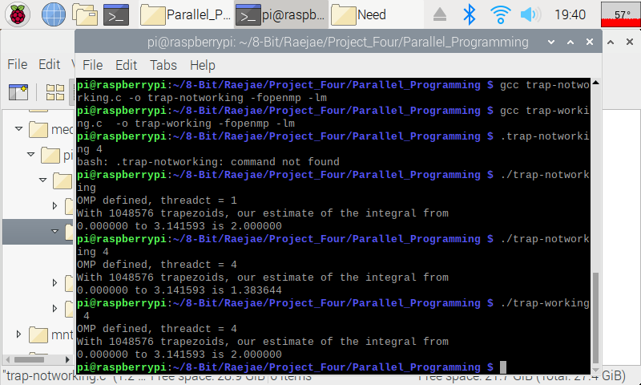For this application I ran both to compare but ran into errors initially and also discovered some new things. The first thing is that the activity didn’t make reference to the Math Library which is why compiling brought forth errors. The other issue is when ran on one core (discovered by accident) we will get our intended answer but multiple don’t give us (2). We initally had integral shared across the forked threads so we ran into issues like this; however, declaring as a pattern fixes this problem.

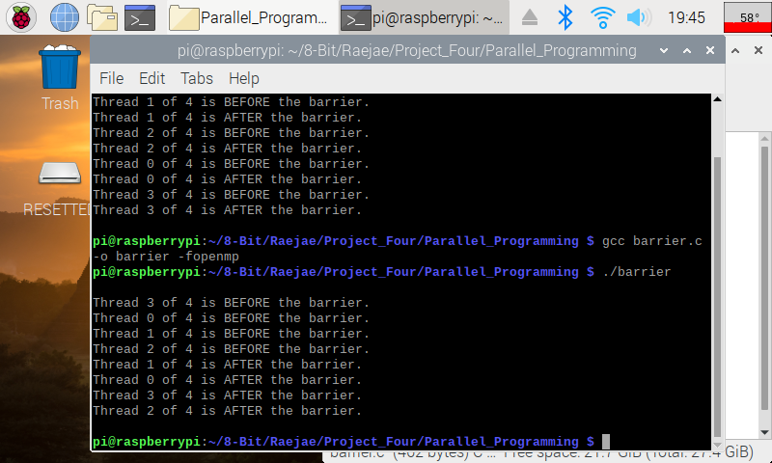**Barrier Program**

If we look closely, we can see that in the initial run the treads were executing really out of sync and there was no management function in place. We notice after uncommenting Pragma that the threads are all aligned before and will wait before execution which manages our program much more efficiently.

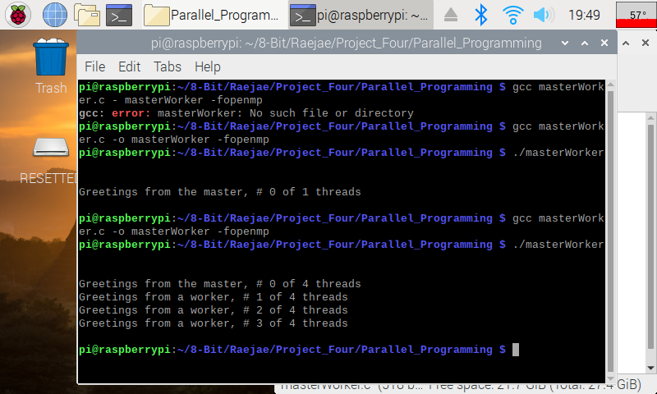 **Master Worker:**

I made an error in loading this however, it was just a typo and after running we can see that we only get one thread returning “Greetings.” We want our program to run in parallel so after uncommenting we notice we receive a message from each thread.

**Parallel Programming Skills**

By: Tony Ngo

1. **What is race condition?** 
   1. Race Conditions happen when one system’s behavior is dependent on the timing of other uncontrollable events.
2. **Why race condition is difficult to reproduce and debug?** 
   1. Since timing is random, the race condition can disappear while debugging, which is also referenced as a “Heisenbug”
3. **How can it be fixed? Provide an example from your Project_A3 (see spmd2.c)**
   1. An example of how this could be fixed is creating instances outside of the portion that initializes the use of OpenMP Pragmas. This is because when you initialize the instances while utilizing the threads, there is room for randomness because we are not sure which threads will be initialized, thus creating a “Heisenbug”.
4. **Summaries the Parallel Programming Patterns section in the “Introduction to Parallel Computing_3.pdf” (two pages) in your own words (one paragraph, no more than 150 words).**
   1. In coding, there are two types of patterns: strategies and concurrent execution mechanisms. There are two primary types of strategies: algorithmic and implementation strategies given the algorithmic strategies. Algorithmic Strategies make choices about which thread to execute concurrently (aka the most efficient way to execute a program), while the implementation strategies contribute to certain processes or the overarching processing unit.

Concurrent Execution Mechanisms are parallel code patterns that enable parallelism or concurrent execution- an example would be OpenMP Pragmas which utilizes multithreading. There are two different concurrent execution patterns: Process/Thread control or Coordination Patterns. Process/Thread control patterns control how many threads/what threads are executed at a time, while coordination patterns set up how many running tasks are needed to complete the pattern. Coordination patterns set up how many threads/processes are going to be setup.

There is a third emerging implementation which utilizes both MPI and OpenMP in one program (hybrid computation), which can run multiple computers in a cluster.

1. **In the section “Categorizing Patterns” in the “Introduction to Parallel Computing_3.pdf” compare the following:**

**o Collective synchronization (barrier) with Collective communication (reduction)**

**o Master-worker with fork join**

* 1. Masterworker takes use of multiple processors through the line of code “#pragmas OpenMP parallel” because we are able to use threading. Collective synchronization is used in barrier because we can see both cases where parallel execution is utilized (before we removed the comments on barrier) and then when synchronized execution is utilizes (after we removed the comments on barrier). Both instances of code are similar in the way that they utilize the OpenMP library to accomplish the threading. However, in Barrier (Collective Synchronization), it utilize both sequential and parallel patterns, while Masterworker only utilizes sequential.

1. **Where can we find parallelism in programming?**
   1. Parallelism is found wherever multithreading is found, so in any video editing application or program that utilizes high level computations.
2. **What is dependency and what are its types (provide one example for each)?**
   1. A dependency is when an operation depends on an earlier operation to produce the result. One type is execution two statements in parallel and another is sequential consistency in parallel execution.
      1. Two statements in parallel

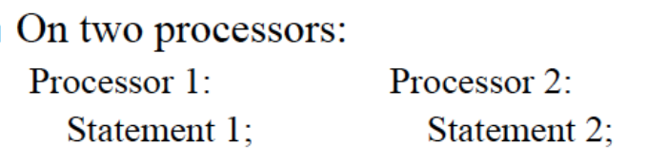

* + 1. Sequential Consistency in Parallel Execution

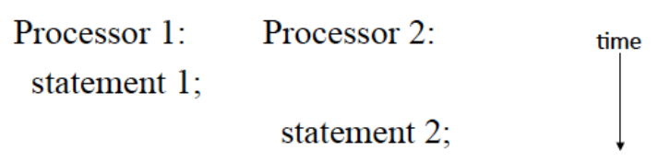

1. **When a statement is dependent and when it is independent (Provide two examples)?**
   1. A statement is independent if the order of execution does not matter. A statement is dependent if the order of the execution will affect the outcome.
      1. Independent Execution

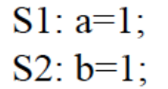

* + 1. Dependent Execution

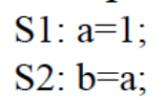

1. **When can two statements be executed in parallel?**
   1. Statements can be executed in parallel when the statement order does not matter and has dependencies.
2. **How can dependency be removed?**
   1. Dependencies can be removed if they are independent of one another.
3. **How do we compute dependency for the following two loops and what type/s of dependency?**
   1. Loop-Level Parallelism
      1. Dependency is calculated within loops
   2. Iteration Space
      1. Undo loop and separate statements/iterations & show dependences between iterations

**Parallel Programming Basics**

By: Tony Ngo

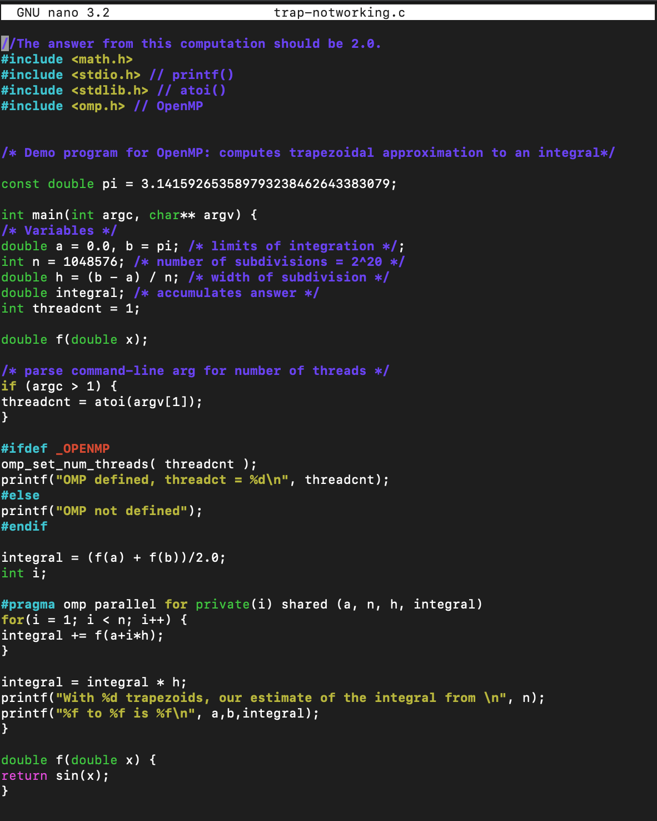

This is the code for trap-notworking.c shown using the nano text editor.

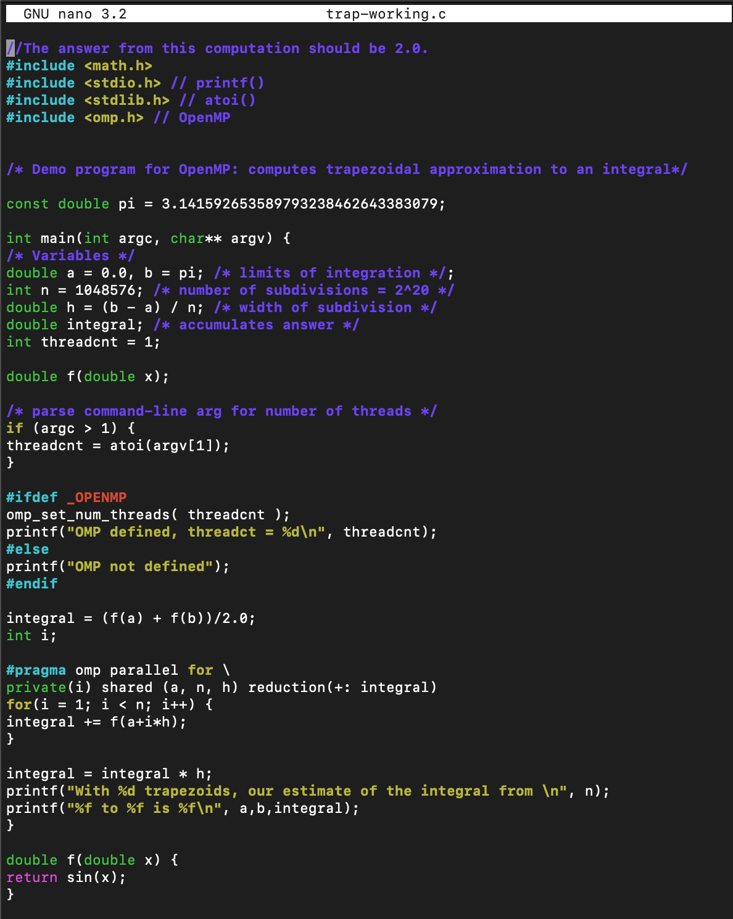

Here is the code for trap-working.c; I also used the nano GNU to write this.

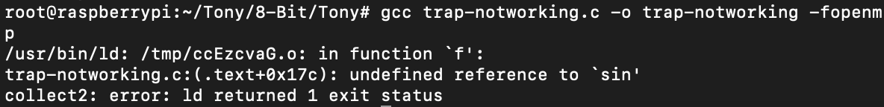

When I tried to compile it using “gcc trap-notworking.c -o trap-notworking -fopenmp”, it would not let me compile because it couldn’t recognize the “sin(x)” portion of my code.



After doing some online research, I was able to find that adding “-lm” fixed it because it is a part of the “math” package.



Here is the compilation for “trap-working.c” using “gcc trap-working.c -o trap-working -fopenmp -lm”, I also wrote it using the nano GNU.

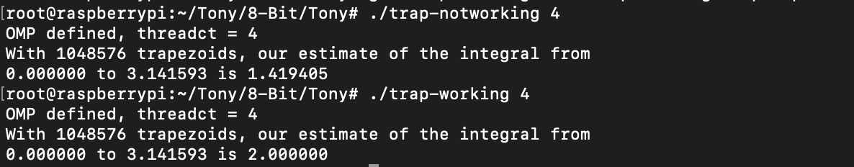

Here is the output for trap-notworking and trap-working. As we can see the correct output was displayed for trap-working. However, trap-notworking is giving an incorrect answer, this is because on line 37 in trap-working, they initialized the value in 37/38 on a separate line, instead of like on line 37 on trap-notworking which initializes it on one line.

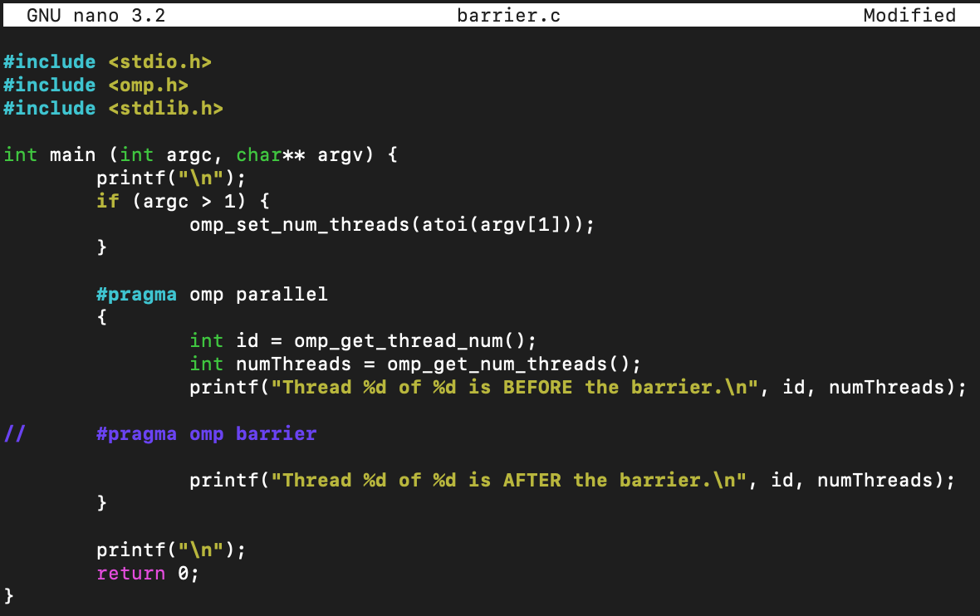

This is what the barrier code looks like with the omp barrier still commented out; this code was written with the nano GNU. I had to re-write the code because copy and paste would mess up the format of the code.

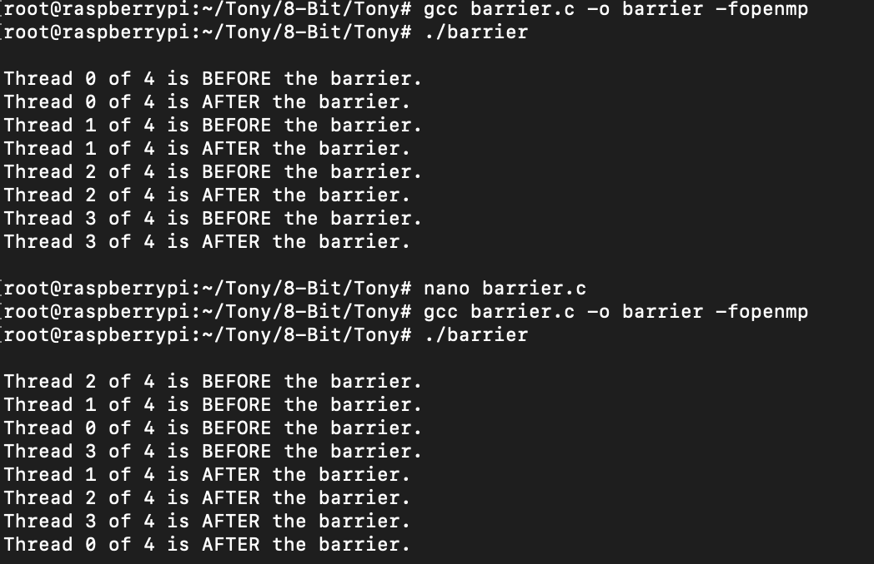

I was able to compile the code easily both times. When you uncomment the omp barrier, it makes the threads run in order instead of parallel. This is because when you uncomment the barrier it is not running in parallel anymore, the threads are now executing in sequential order.

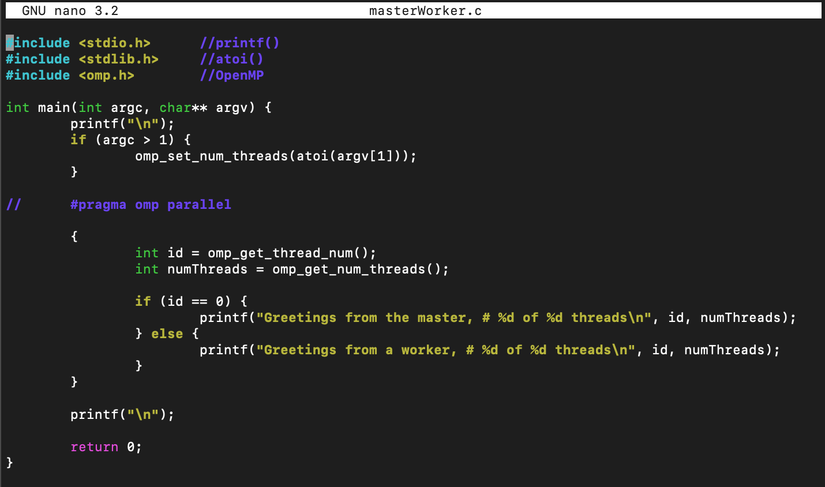

This is what the masterWorker.c code looks like with the pragma OpenMP parallel commented out; this code was written using the nano GNU. I also had to write the code instead of copying it over because the code because the formatting was messed up.

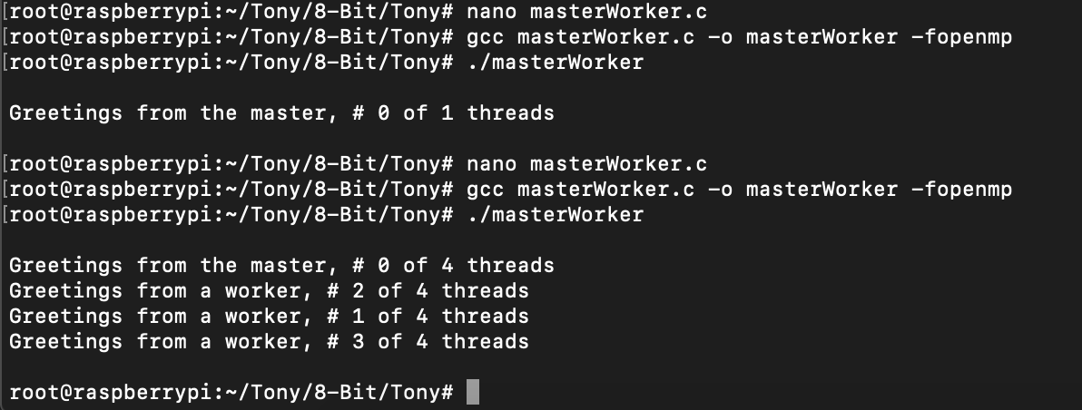

This is the compilation using “gcc masterWorker.c -o masterWorker -fopenmp” of masterWorker before and after the uncommenting of the pragma OpenMP parallel. Before we uncommented it and ran the code, there was only one thread running at a time, after we uncommented and ran the code, there was four threads running at a time. This is because when the code is commented, we did not utilize threading, but after we uncomment it, the code utilizes all threads.

**ARM Assembly Programming**

**ARM Assembly Programming**

By: Landon Wang

**Part 1: Fourth Program**

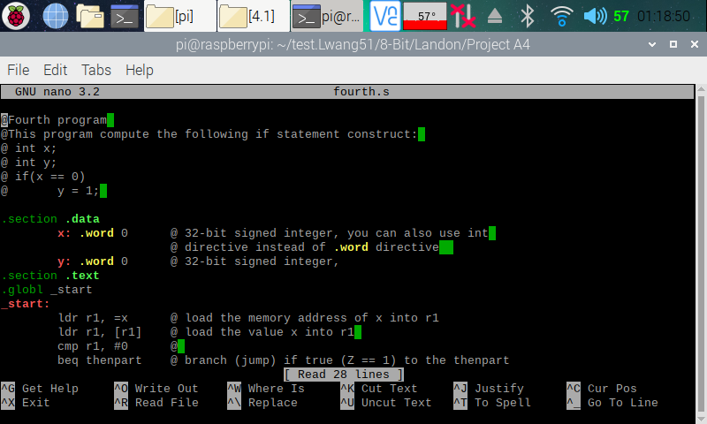

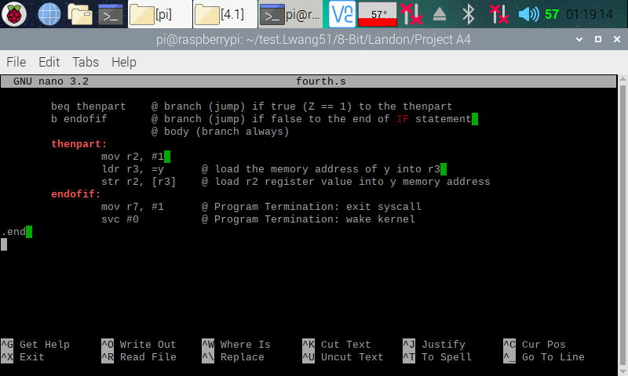

Here (in the two screenshots above), I copied and pasted the codes from the ARM Assembly Programming A4 document and used the nano editor to create a program on my Raspberry PI.

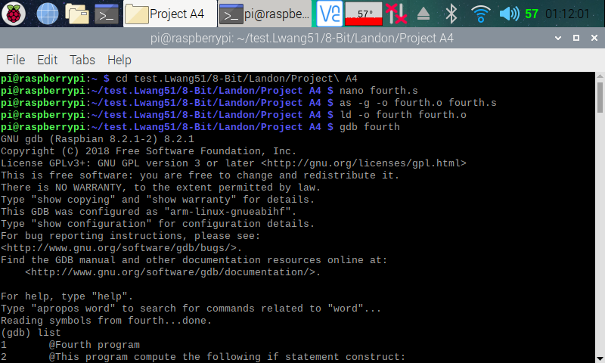

Here (in the screenshot above), I assembled and linked the fourth.s program. I then entered the GDB debugger.

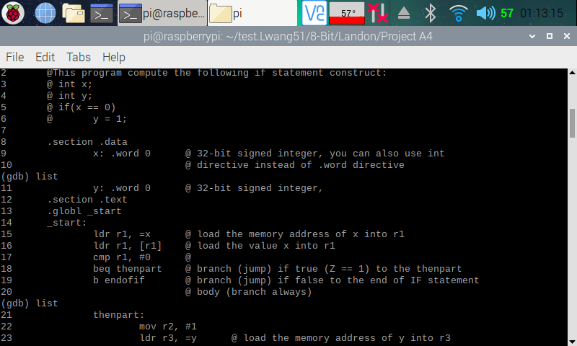

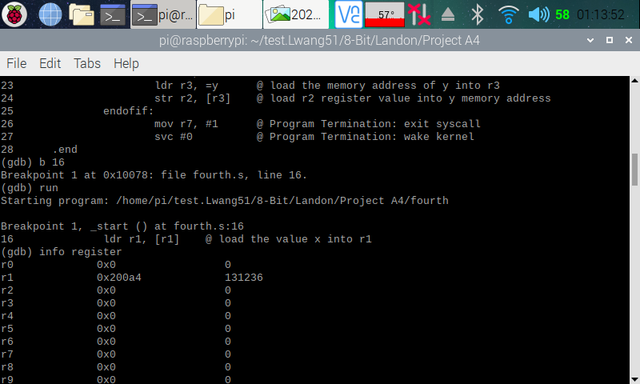

Here (in the two screenshots above), I displayed my program out in the debugger for easy reference, then set a breakpoint at line 16. I then ran the debugger. Once the debugger executes the line 15 of the code, I pulled up the register information, and we can see that a memory address has been loaded onto r1 as expected from the code (ldr, r1, =x).

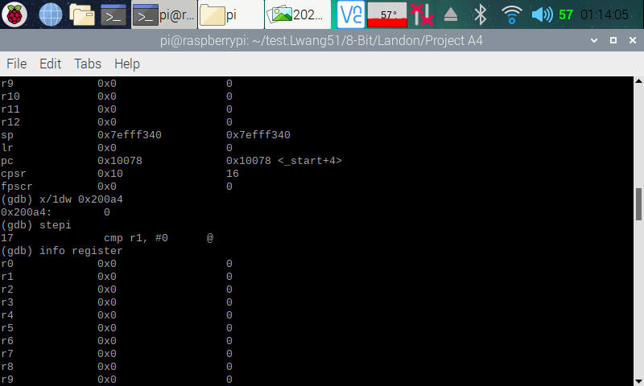

Here (in the screenshot above), I pulled up the memory of the memory address that was loaded onto r1, and we can see that it points to 0 as expected, as we assigned the number 0 to variable ‘x’. I then stepped over to the next line so that line 16 (ldr r1, [r1]) can execute. I then pulled up the register information, and we can see that 0 has now been loaded onto r1.

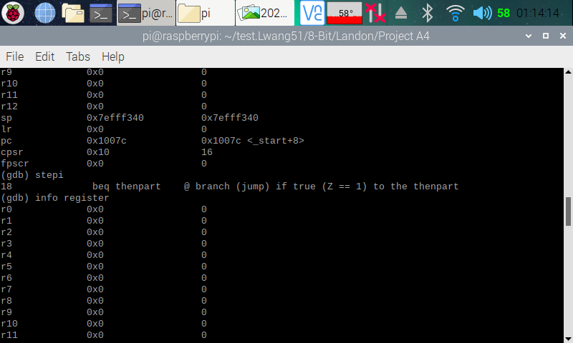

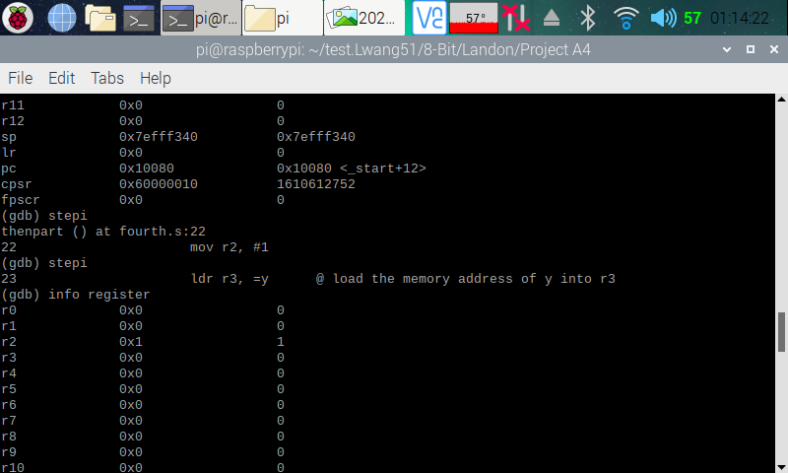

Here (in the screenshot above), I stepped over to the next line so that line 17 can (cmp r1, #0) can run. I then pulled up the register information. Looking at the CPSR flag register, we can see that the zero flag (second bit), has been raised. This means that r1 equals 0, which is true, because 0 = 0. I then stepped over to the next line so that line 18 (beq thenpart) can execute. We can see that the program is executing correctly, because it branched to thenpart to set a breakpoint instead of continuing with setting the breakpoint at line 19 (b endofif). This is because we have beq, which means branch if equal, in which it was. I then stepped over to the next line, so that line 22 (mov r2, #1) can execute. I pulled up the register information, and we can see that the number one has been moved to r2.

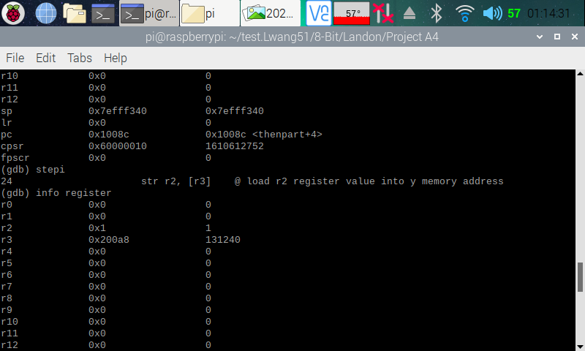

Here (in the screenshot above), I stepped over to the next line so that line 23 (ldr r3, =y) can execute. I pulled up the register information, and we can see that a memory address has indeed been loaded onto r3.

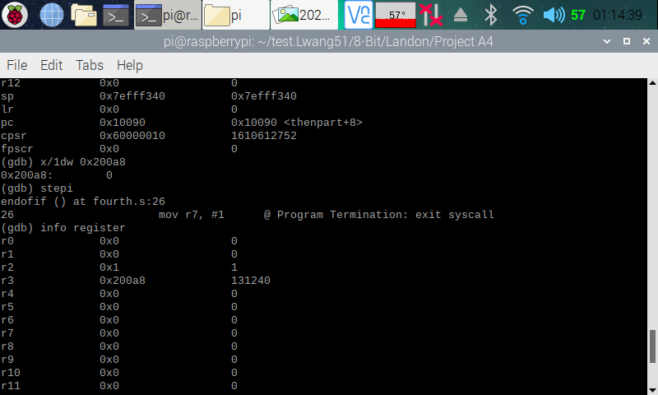

Here (in the screenshot above), I pulled up the memory with the memory address in r3, and we can see that it is pointing to 0. This was expected, because we assigned the number 0 to variable ‘y’. I then stepped over to the next line so that line 24 (str r2, [r3]) can execute. I changed up the code here a little, because I believe there was some issue. The original code for line 24 was ldr r2, [r3], which did not produce the correct output as stated in the comment (this is shown at the end of this section). I then pulled up the register and we can see that there is a memory address in r3.

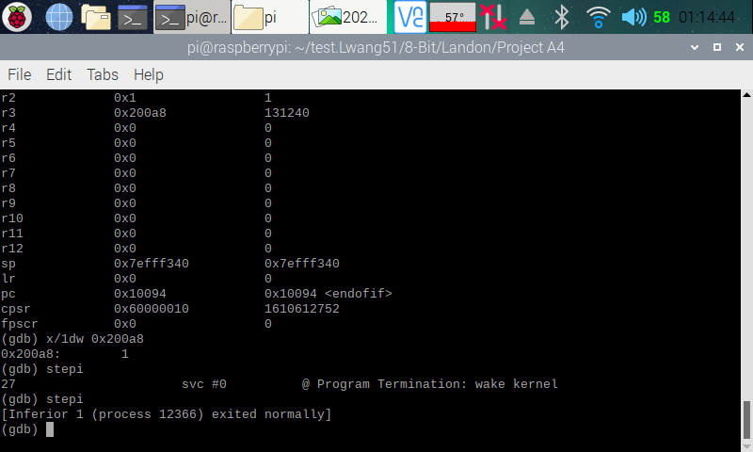

Here (in the screenshot above), I pulled up the memory using the memory location in r3, and we can see that it now stores a 1 instead of the 0. We now know that our program is executing correctly.

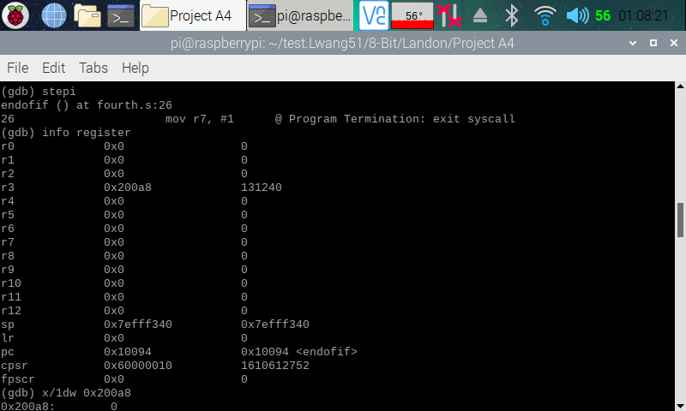

Here (in the screenshot above), is the register from the program when line 24 had ldr r2, [r3] instead of str r2, [r3]. I pulled up the memory register and the memory and we can see that the memory address points at a 0, which was not what the comment wanted the program to do. The comment stated to load r2 register value (which should be 1) into ‘y’ memory address. However, ldr r2, [r3] will load the r3 value, which is 0 onto r2, hence the reason why we are seeing a 0 in r2 instead of 1. Because of this, I suspected that there was a typo of some kind, so I changed up the code.

**Part 1: Fourth Program (Improved)**

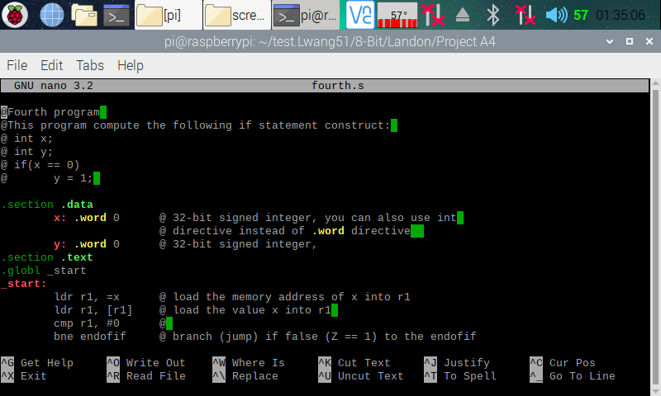

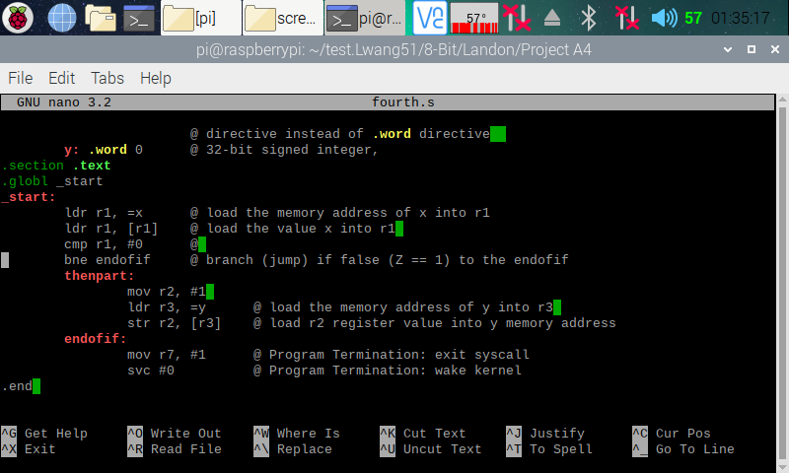

Here (in the two screenshots above), I copied and pasted the codes from the ARM Assembly Programming A4 document and used the nano editor to create a program on my Raspberry PI.

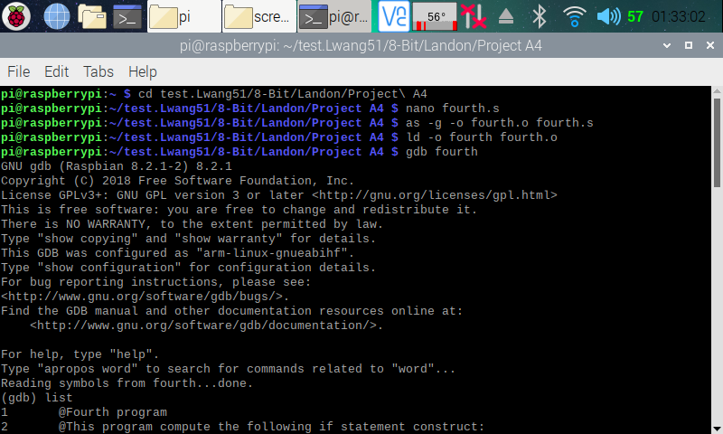

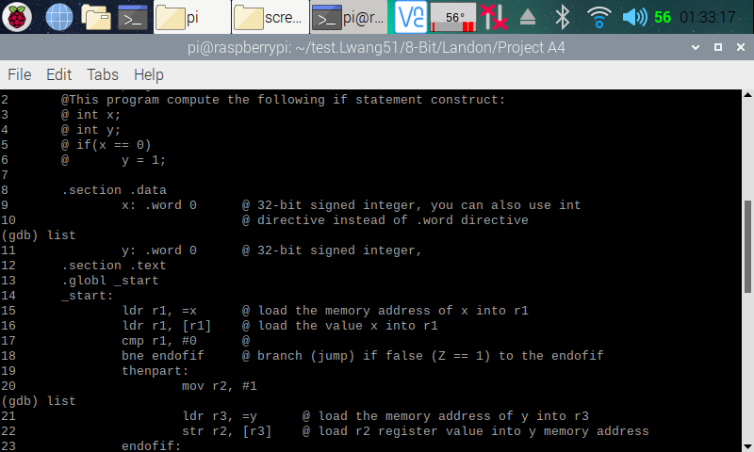

Here (in the two screenshots above), I reassembled and relinked the fourth program after changing “BEQ” to “BNE” and removing the original line 19 (b endofif) in the code. I then entered the GDB debugger and displayed the code for easy reference.

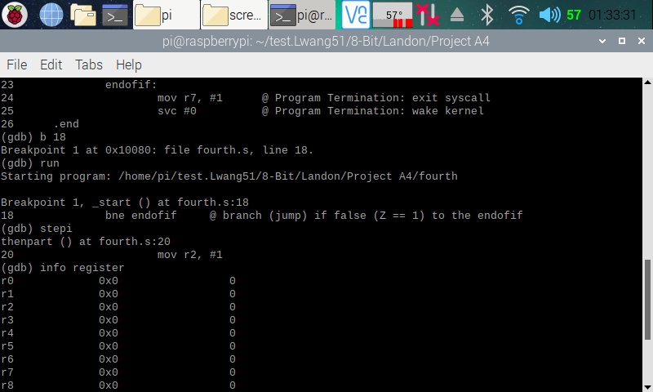

Here (in the screenshot above), I set the breakpoint to line 18, since we already proved earlier that the codes before line 18 works perfectly and that we only need to check the coded after line 17. I then ran the program and stepped over to the next line of code so that line 18 (bne endofif) can execute. We can see that it did not jump, because the zero flag is raised in the CPSR register (as shown earlier). This means that r1 and 0 are equal, and they are (0 = 0). It will only branch if r1 and 0 are not equal.

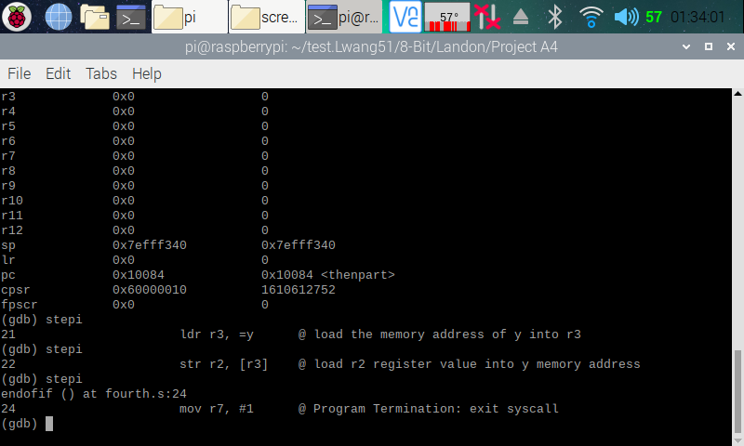

Here (in the screenshot above), I ran through the rest of the program, and everything ran as expected and like the old version of the program.

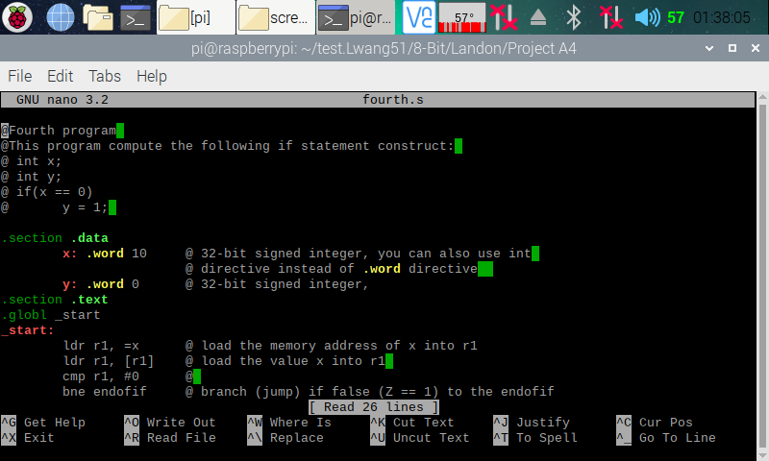

Here (point he screenshot above), I I went back to the code and changed the variable ‘x’ to equal 10 instead to 0 to verify that my code is running correctly.

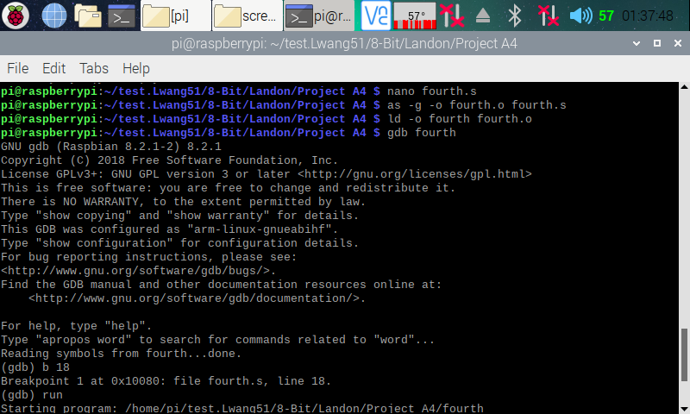

Here (in the screenshot above), I reassembled and relinked my program and entered the GDB debugger. I set a breakpoint at line 18 and ran the program.

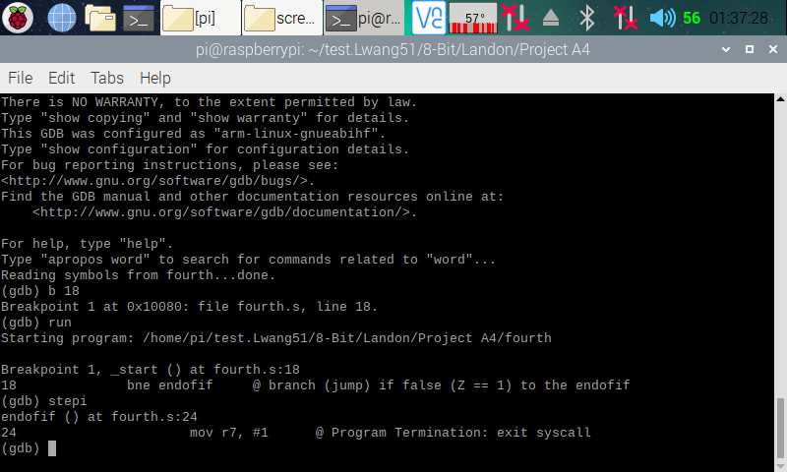

Here (in the program above), I stepped over to the next line, and we can see that the program branched to endofif, because the zero flag in the CPSR register was not set, meaning r1, which stores x (10) does not equal 0, and this is correct (10 != 0). I now know that my program is running correctly.

**Part 3: Control Structure 1 Program**

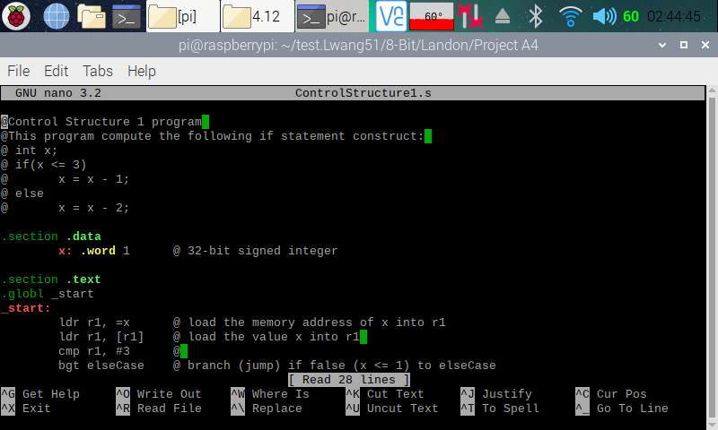

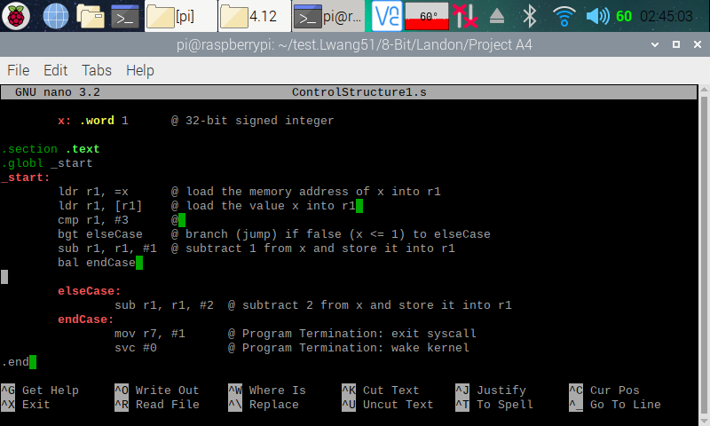

Here (in the two screenshots above), I copied and pasted the codes from the ARM Assembly Programming A4 document and used the nano editor to create a program on my Raspberry PI.

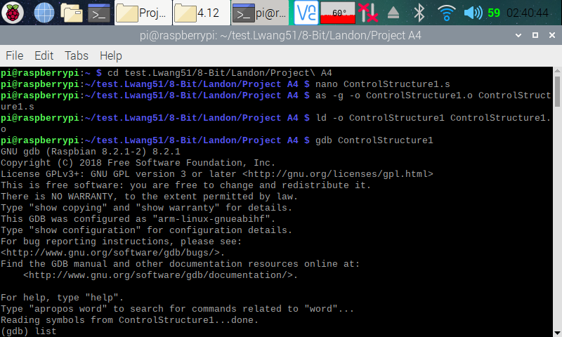

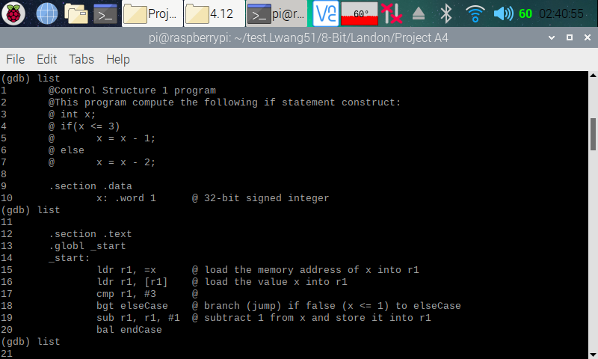

Here (in the screenshot above), I assembled and linked the ControlStructure1.s program. I then entered the GDB debugger. In the debugger, I displayed my code for easy reference.

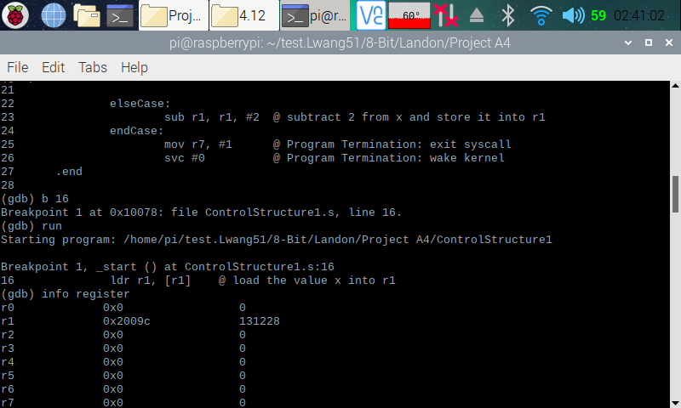

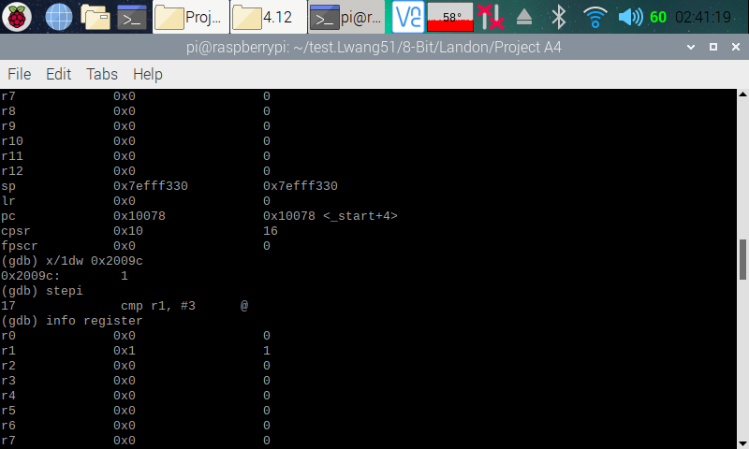

Here (in the two screenshots above). I set a breakpoint on line 16 and ran the program. I then pulled up the register information, and we can see that a memory address has been loaded to r1. I then pulled up the memory using the memory address, and we can see that it is currently pointing to 1. This was as expected, because we assigned the number 1 t variable ‘x’. I then stepped over to the next line so that line 16 (ldr r1, [r1]) can execute. I then pulled up the register information, and we can see that 1 is now loaded onto r1.

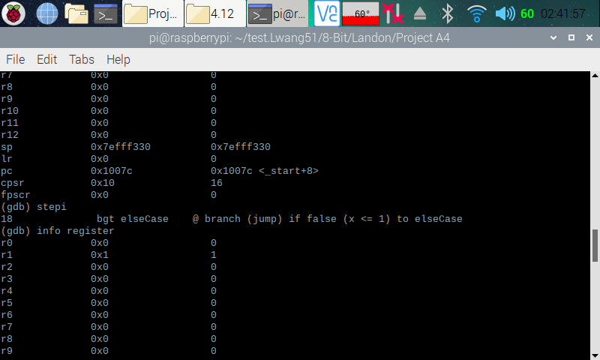

Here (in the screenshot above), I stepped over to the next line so that line 17 (cmp r1, #3) can execute. I then pull up the register information.

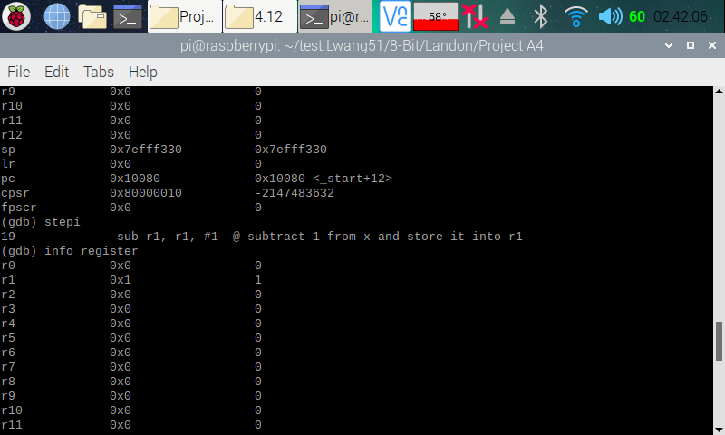

Here (in the screenshot above), I can see that the zero flag is set in the CPSR flag. I then stepped over to the next line so that line 18 (bgt elseCase) can execute. The program did not branch, because 1 was not greater than 3. As a result, the breakpoint was set on line 19.

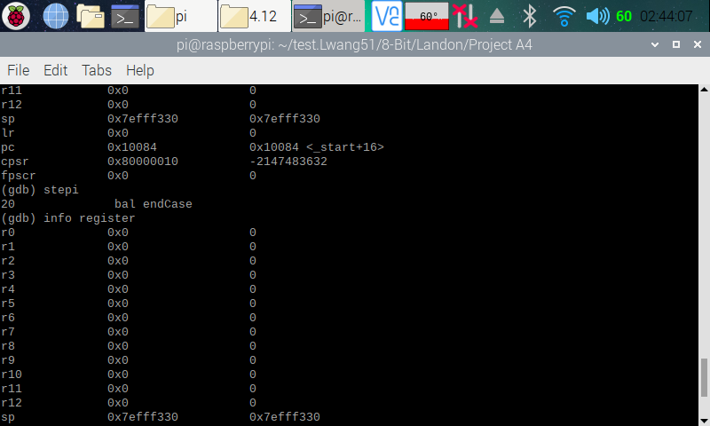

Here (in the screenshot above), I stepped over to the next line so that line 19 (sub r1, r1, #1) can execute. I pulled up the register, can we can see that r1 now stores 0 in it as expected (1 – 1 = 0). The x value in hex is 0, and the Z flag is 1.

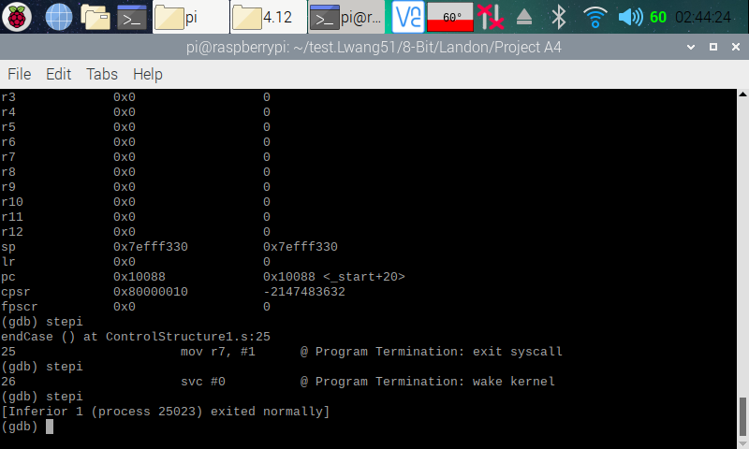

Here (in the screenshot above), I continued with the program until it hits an end. We have 1 stored in r1, and now I know my program is running correctly.

**Arm Assembly Programming**

By: Raejae Sandy

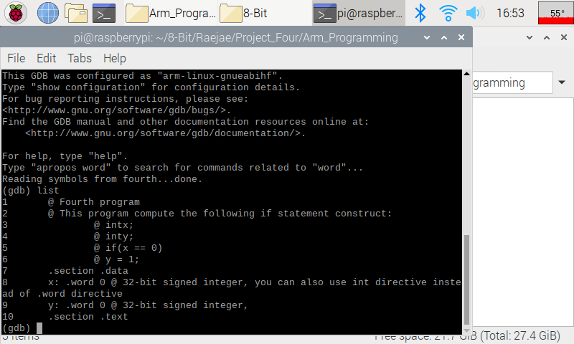A lot happens in this code but the one thing we want to remember is that if the value is equal to 0 then y will be 1. Deviations from this shows we have an issue, and there were discrepancies over the execution of this code within our group as there may have been an error. However the made thing to focus on is how the code handles if statements with their version of the zero flag and jumps.  
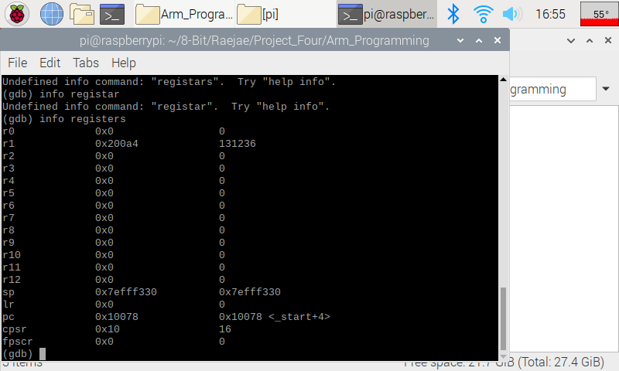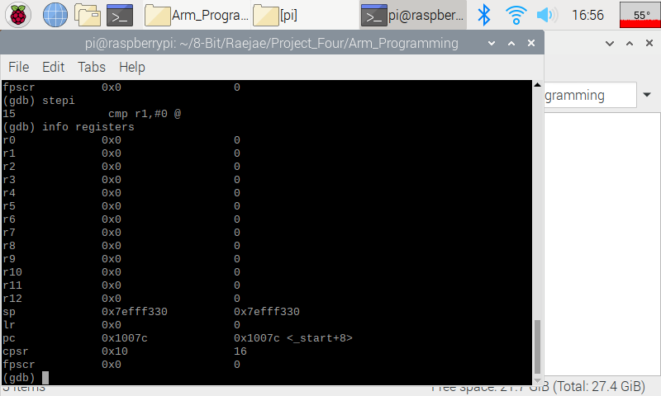  
  
Here we’re simply loading our numbers, and if we pay attention we see the addresses being filled.   
  
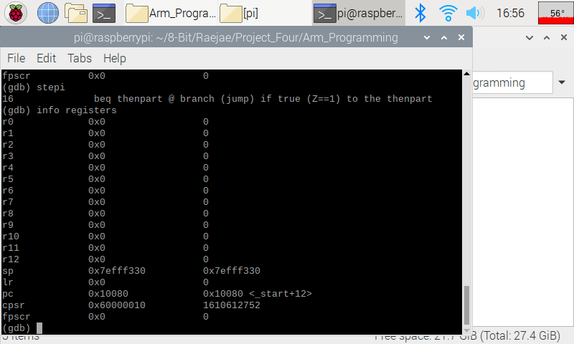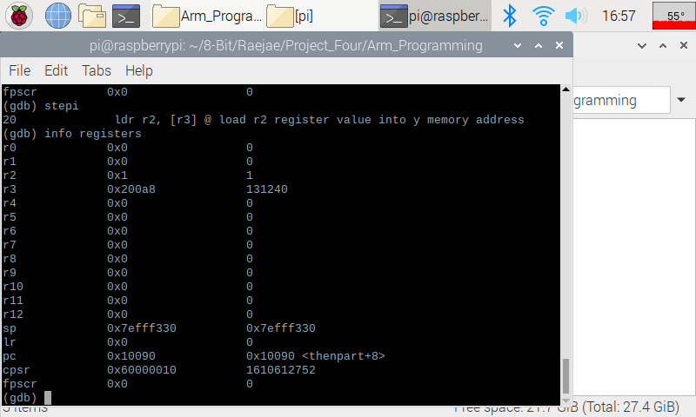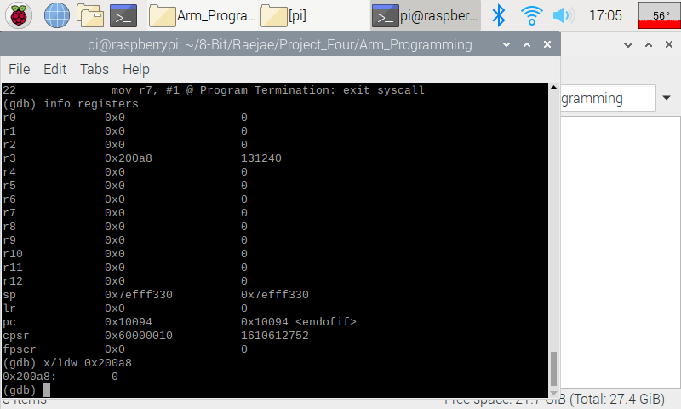  
  
--------  
Improved   
  
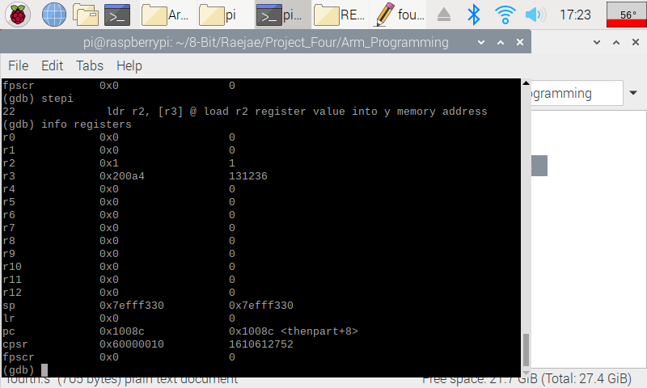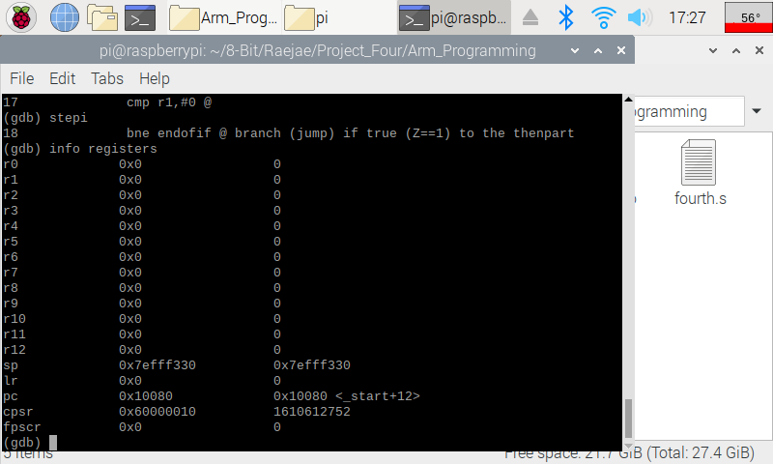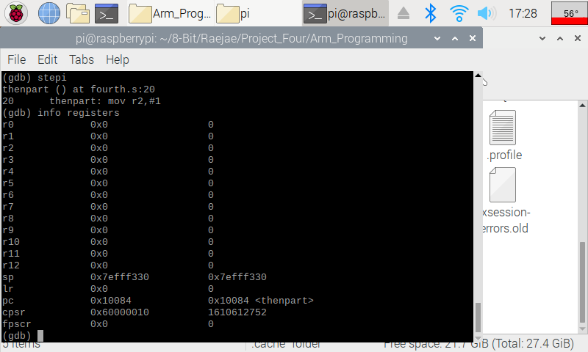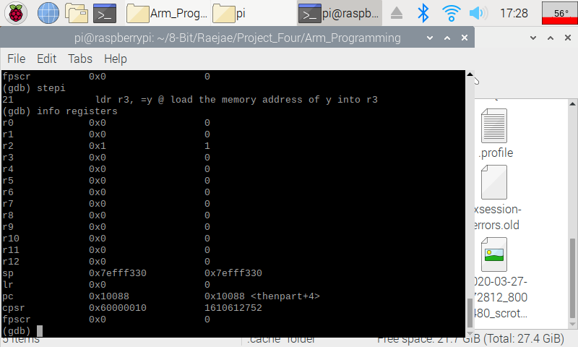  
  
I felt it would be easier to explain by showing the improved version and then explaining the intended output of the code. In the improved version the main thing we need to look at and understand is beq vs ben in the code jumping. The CPSR flag is our Zero Flag determinant and will dictate how these operate and since the results are equal to zero on both we will get our code flowing. What we want is for the code after line 18 to take our result and update and only access the in-between code if the resultants are not equivalent to zero. We get this result albeit we have to make sure we store properly in registers after our jumps.

Control:

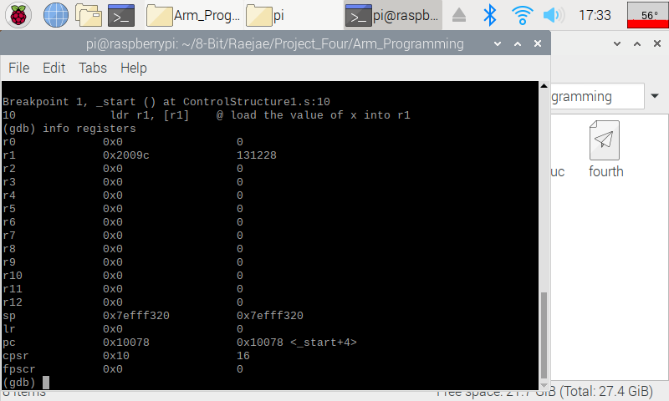  
First thing first we want to make sure we set our values and memory addresses up correctly. If we pull it up we will indeed get one.

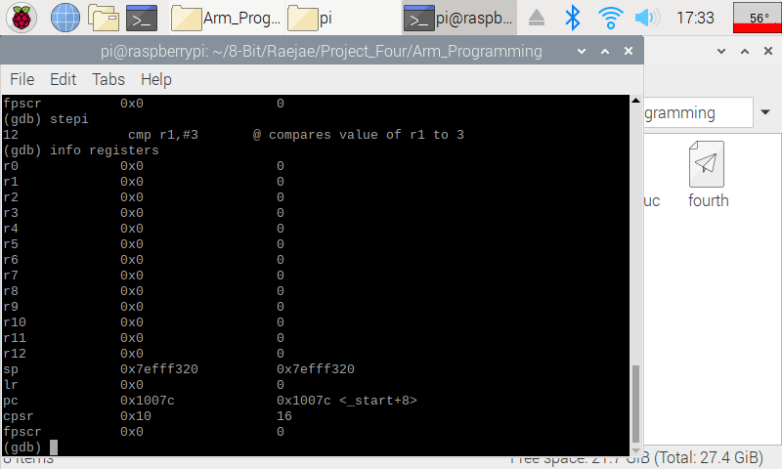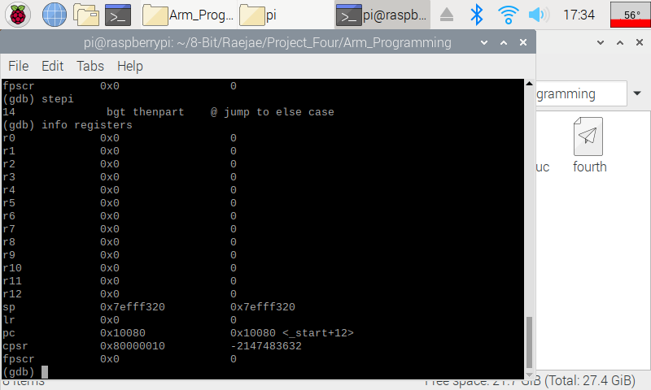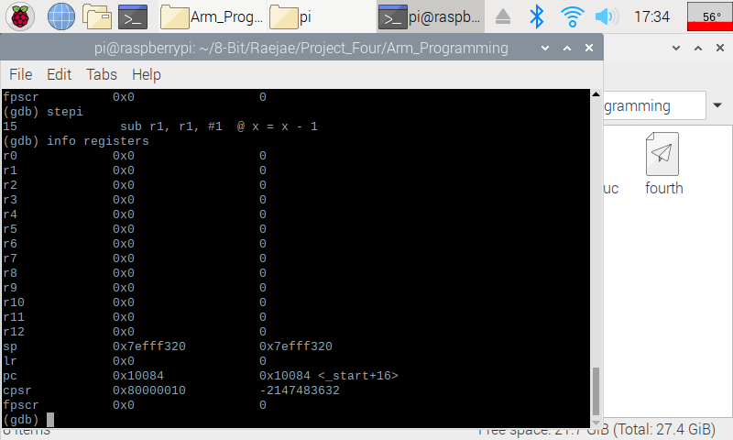  
  
The important thing to notice here is that we’re comparing R1 to a value. We can sub any value but if the difference is there we will branch or not. We don’t have a value greater than the compared so we will set our breakpoint elsewhere.   
  
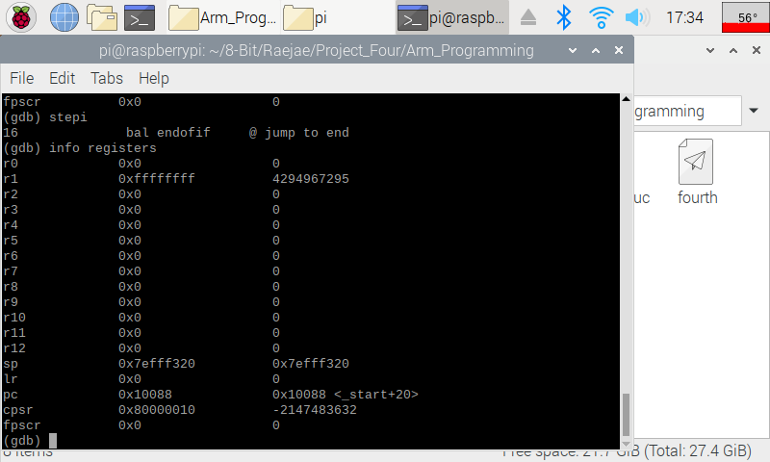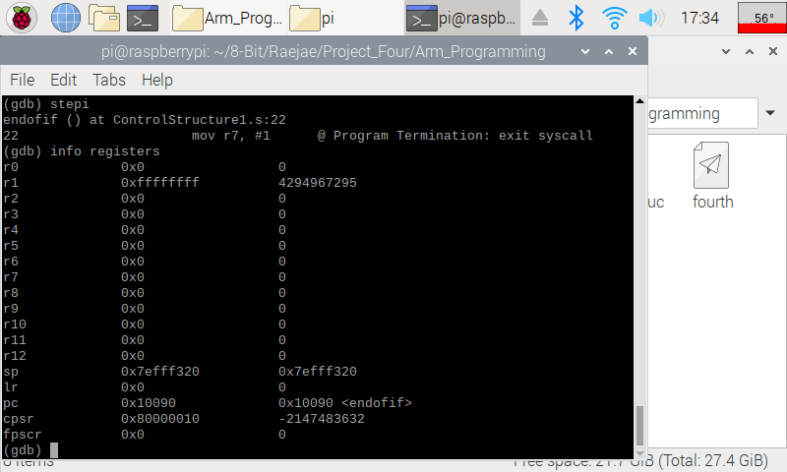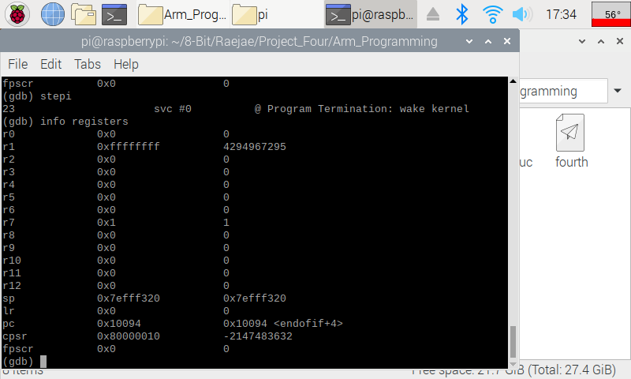  
Our code will execute the following based on what is compared above jumping to either the elseCase or the EndCase and in this case jumping out.

**ARM Assembly Programming**

By: Tony Ngo

Part 1

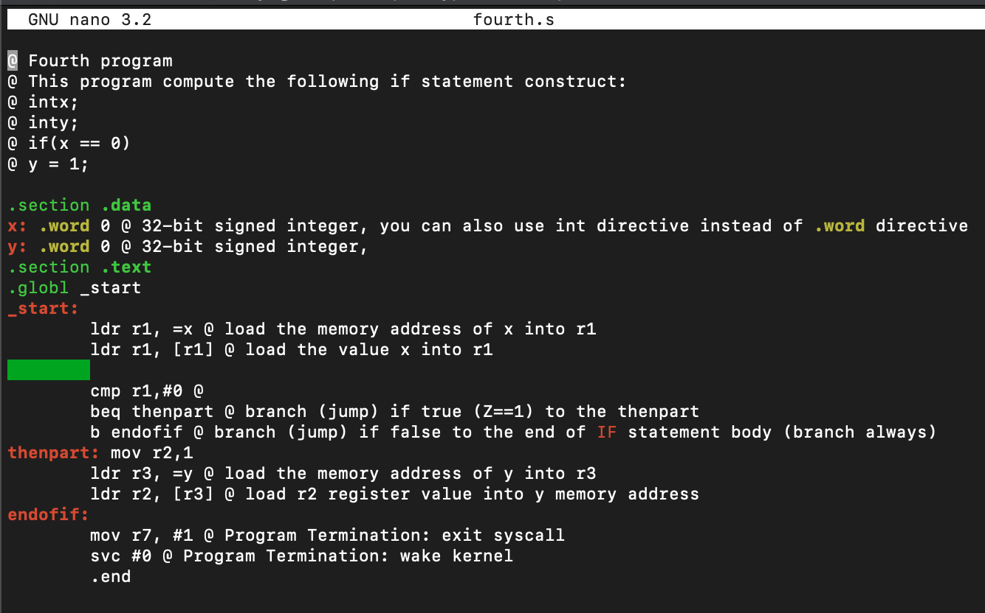

This is the code for the “fourth” program, it was written in the Nano GNU.

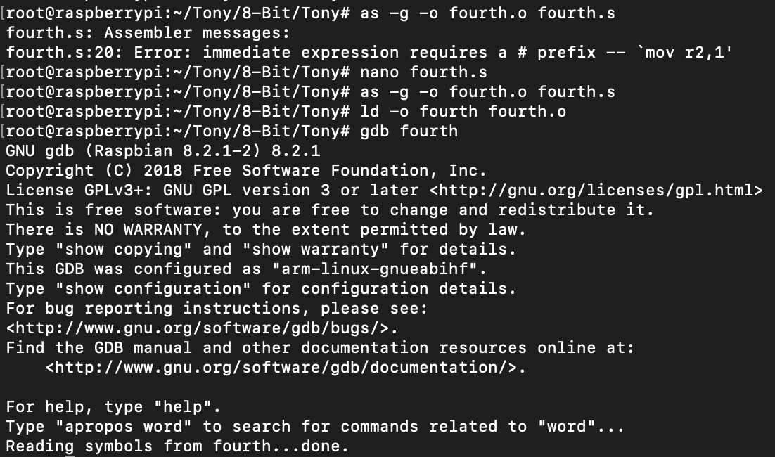

When I originally compiled it using “as -g -o fourth.o fourth.s”, I came into an error on line 20 where the immediate value 1 did not have a # behind it. So I put that in and was able to compile, then I linked the code using “ld -o fourth fourth.o”. I then used “gdb fourth” to debug the code.

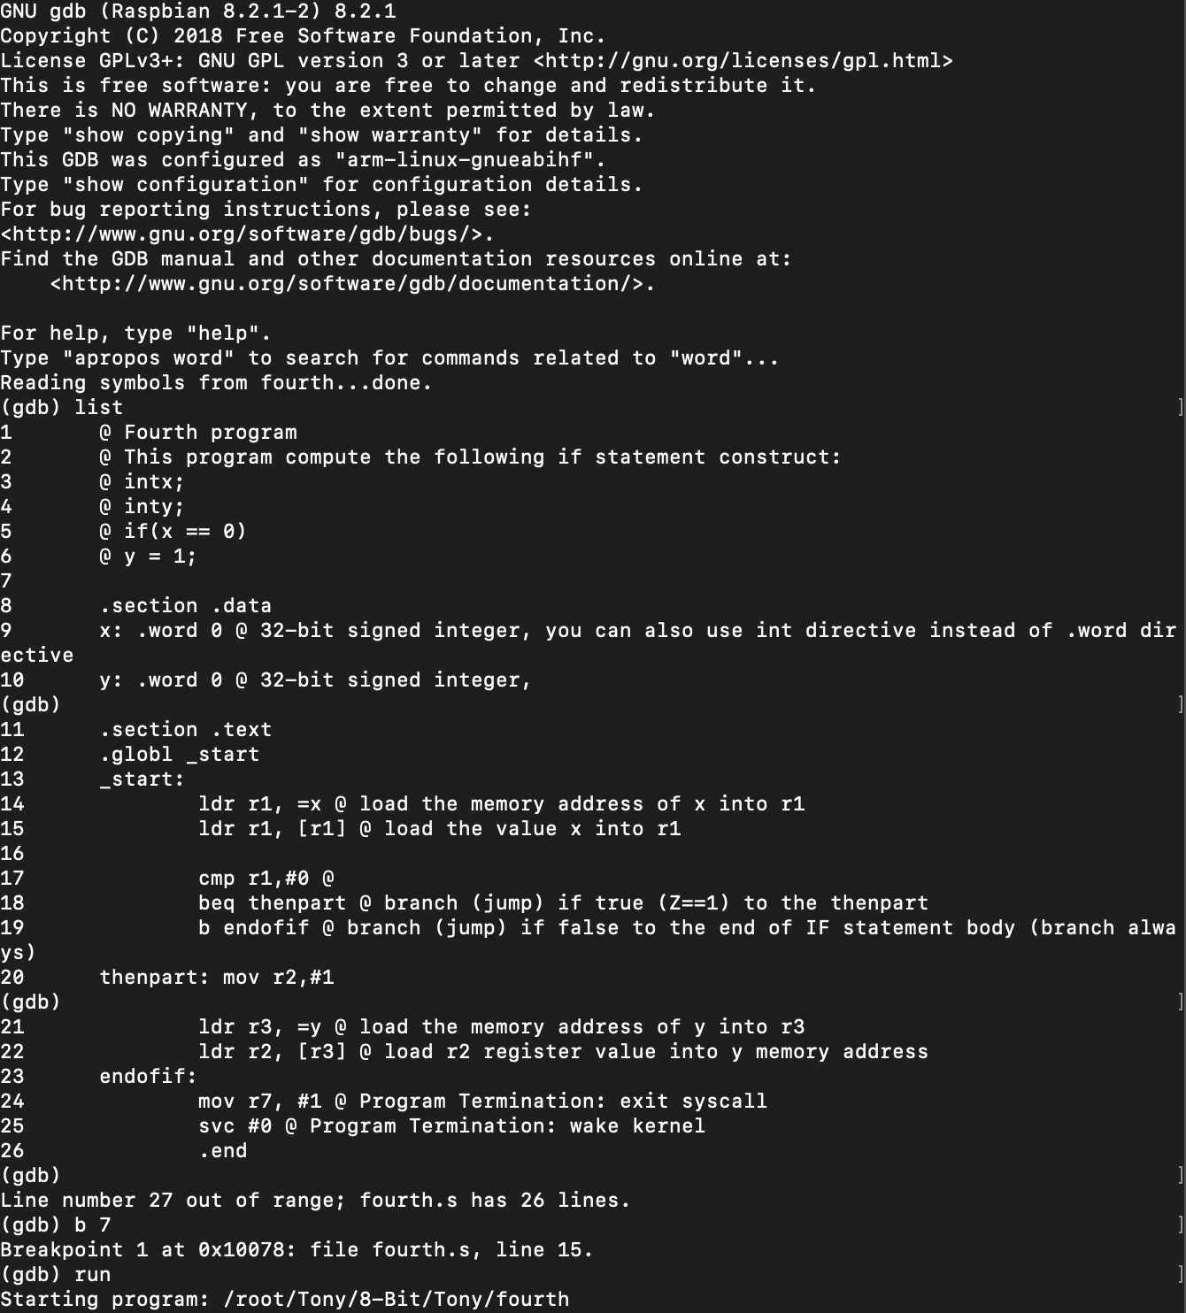

This is the beginning of the gdb debugger which I opened using “gdb fourth”. I used “list” to show all of the code written, then used “b 7” to set a breakpoint at line 7, and finally ran the program using “run”.

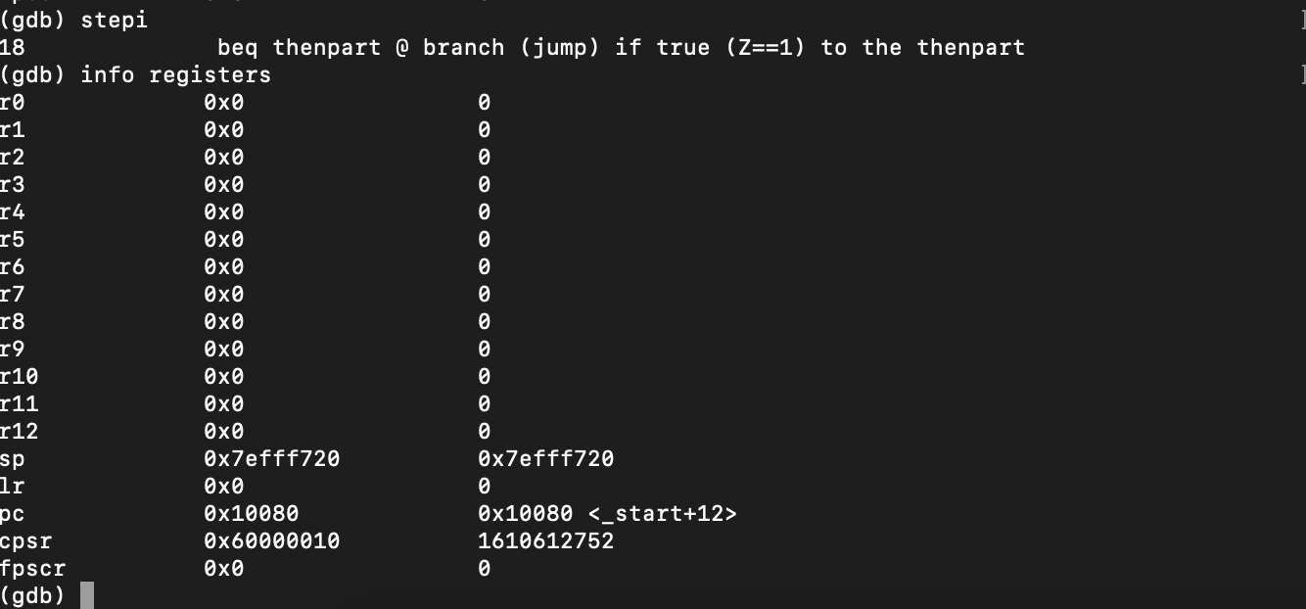

I used “stepi” to keep stepping through the code and used “info registers” to check at each step if the registers changed, and I got to line 17 and was able to find that the register for the zero flag was up, and that’s because in the line before we set the zero flag, and afterward jumps to line 20 because it was true that z==1.

Part 2

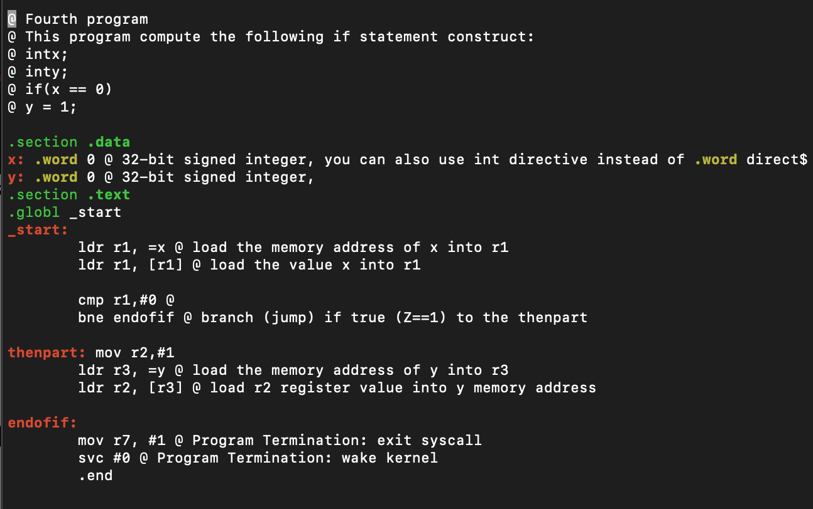This is the updated fourth.s from Part 2, I used the Nano GNU to write the program. In the project instructions it tells us to add “bnq”, but the function is actually “bne”.

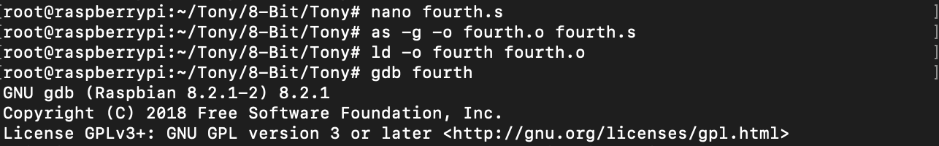

I compiled the code using “as -g -o fourth.o fourth.s”, I then linked the code using “ld -o fourth fourth.o”, and showed the gdb debugger was working after I used the function “gdb fourth” and the debugger opened.

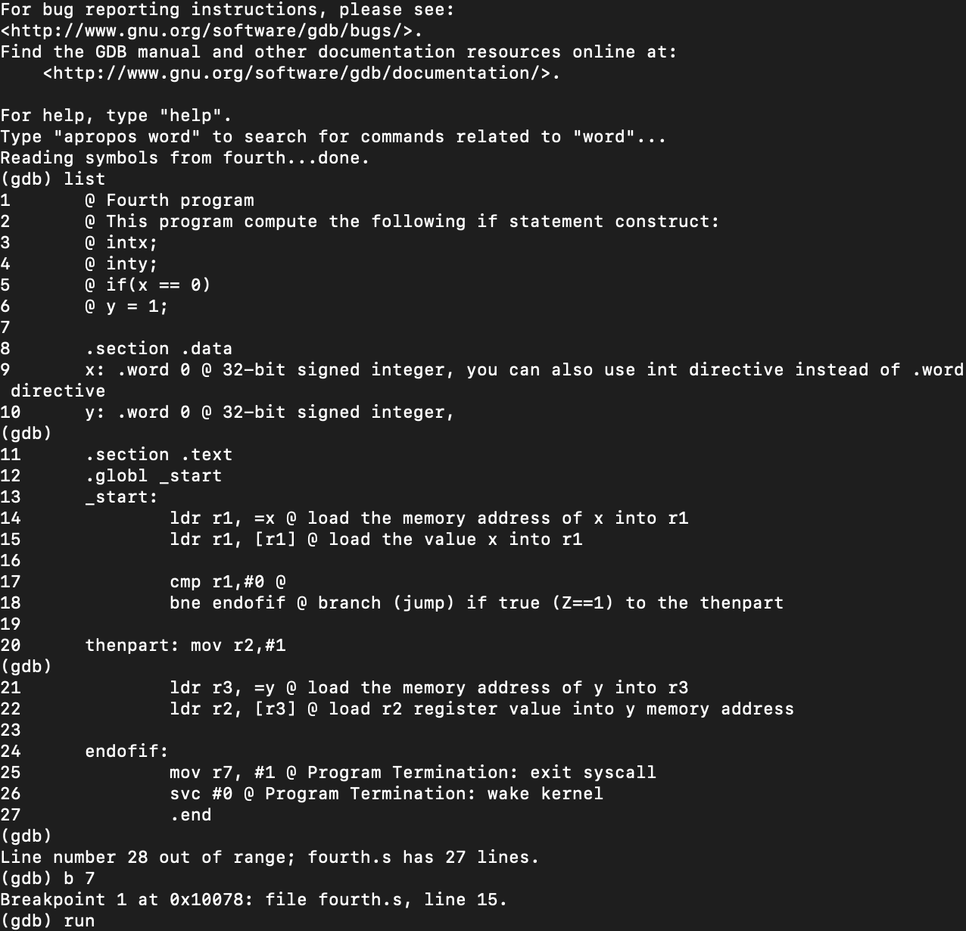

I used “list” to show my code, and then set “b 7” to be my breakpoint and used “run” to start the execution.

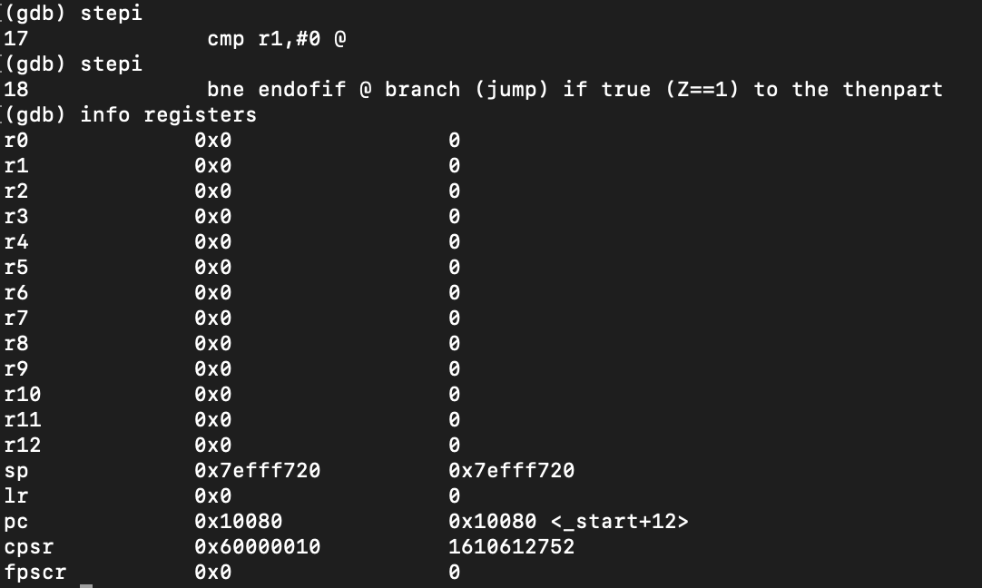

I used “stepi” to step through the code and “info registers” to check the value of the registers at each step increase. In “cpsr”, the zero flag was still up, and the code just went to “thatpart” because it did not need to jump since b was equal.

Part 3

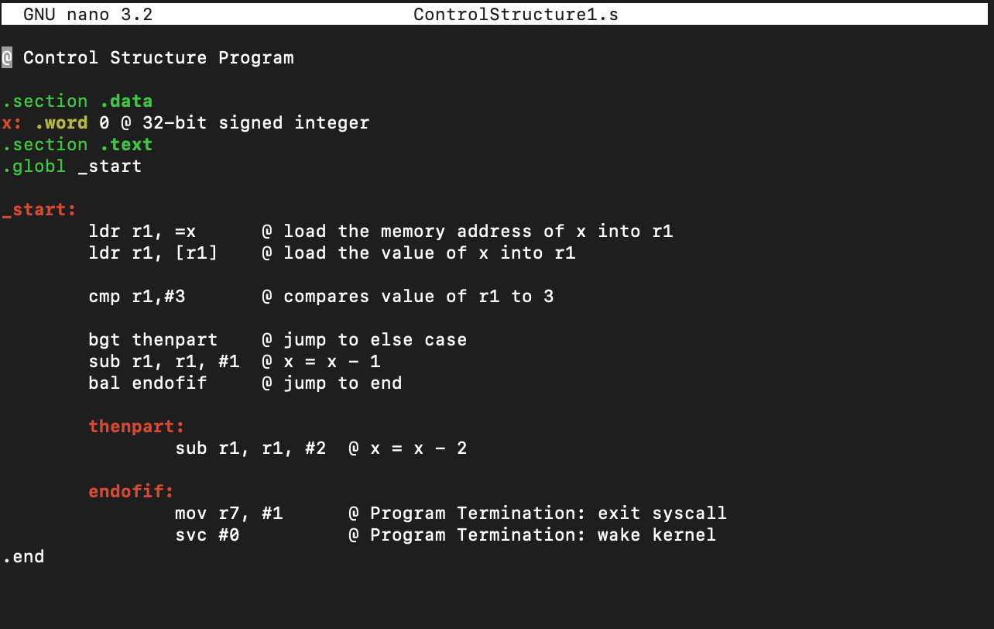

This is my code for the ControlStructure1 program; I used the nano GNU to write the code. I used bgt instead of ble because when creating code in assembly, you have to have it move in logical order, and if you use “ble” the code will not be in sequential order, which creates inefficiency in the code.

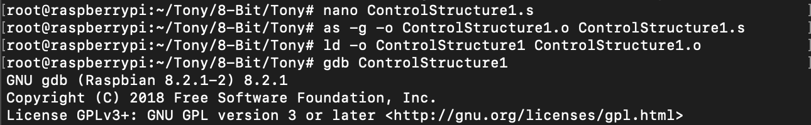

I used as -g -o ControlStructure1.o ControlStructure1.s to assemble the program, and then used “ld -o ControlStructure1 ControlStructure1.o” to link the program, and then used “gdb ControlStructure1” to open up the GDB debugger and confirmed that it was working.

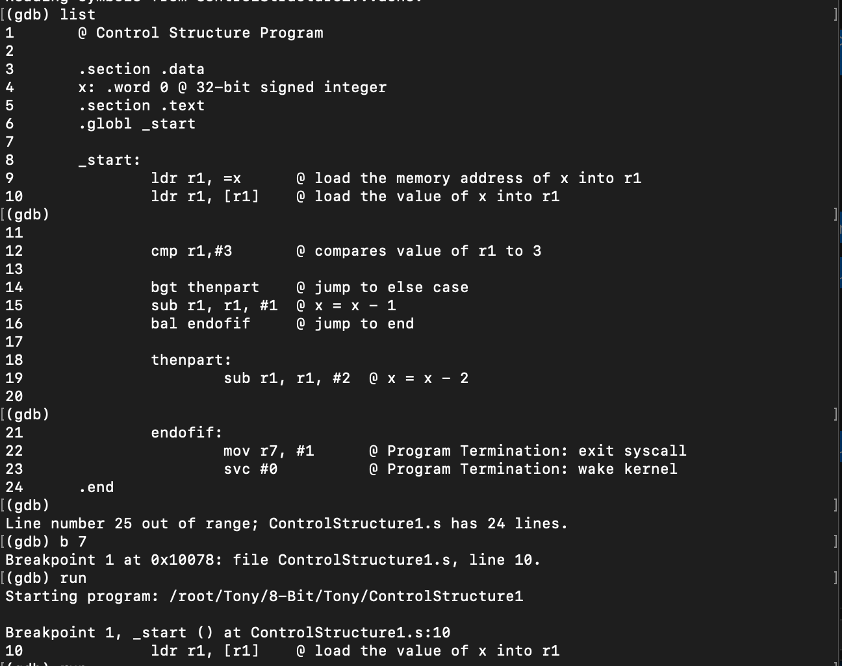

I used “list” to show my code, then I used “b 7” to create a breakpoint at line 7, then I ran the code using “run”.

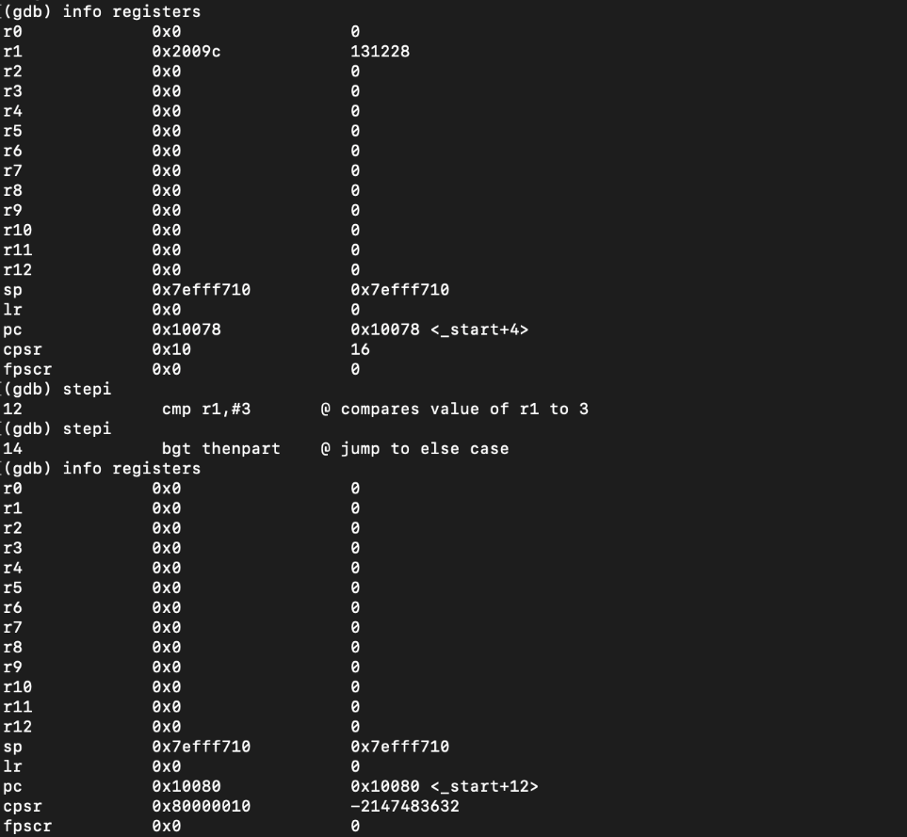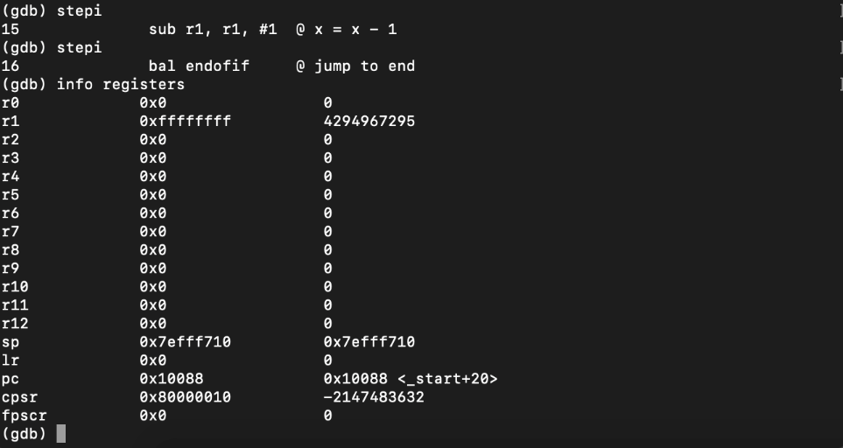

I ran my code and this was the result. It is correct because I set my value of “x” as 0, and since 0 > 3 is not true, it just went to the next step and subtracted 1 from 0 (which is correct because 0xfffffff is -1) and jumped over “thenpart”.

**Appendix**

Slack: <https://app.slack.com/client/TTK19C222/CTGQG7H7A/user_profile/UTGB5U71S>

GitHub: <https://github.com/Rsandy2/8-Bit>

Presentation on YouTube: <https://youtu.be/LdJlvphc2L8>

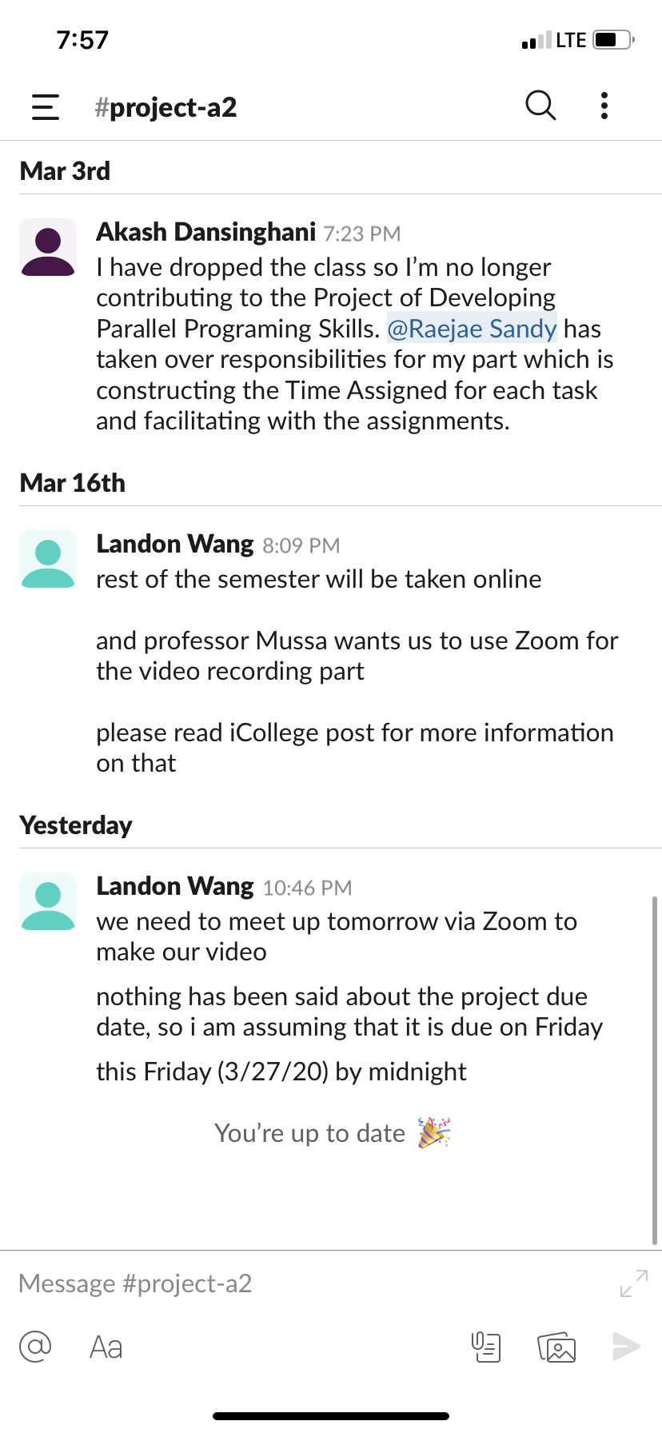Screenshot of Slack Chat: